Redback Racing Process and Notes:
  - Goal
The Goal of this TA is to:
- Make sense of given data from the CAN bus captures
- Write a program so the motors can move at a commanded angle smoothly without overshooting or crashing.
Debrief steps:
- Take the raw CAN data and decode them using DBC and log file (.dbc) and convert it into a clean spreadsheet data using CSV (.csv) so the data can be studied about how the motor moves.
- Model the actuator using mathematical representations that mimics the original actuators behaviour.
- Program a PID control loop that helps keep the angle steady for the motor (target driver angle).

Glossary for understanding:
Part 1: Core terms and Vocabulary:
Plant: The physical thing being controlled which is the steering actuator motor.
Controller: the software program to sends commands to the plant.
CAN Bus (Controller Area network bus): This allows the electronic components to communicate with each other without a main central unit and complex wiring. Instead it is connected by two wires to send the information from one ECU to another.
CAN Frame: used by ECUS to communicate with each other
CAN sniffer: logs real-time data from the CAN Bus network.
ECU (Electronic control unit): A small electronic component that controls a subsystem of the vehicle or machine which sends or receives data from other ECU’s.
CAN High and Low: This is a significant part of the system, a two wired system that connects the ECU’s with one-another rather than a large complex system. Thus, creating a simple yet efficient communication system. Additionally, it communicatees to the ECU via voltage difference which gives simple clean signals, preventing distortion via a dual-wired system. Briefly, CAN high drives voltage up and CAN Low drives voltage down to create a gap, say there is a burst of static from the car which added 1 volt of distortion to the wires, both lines go up by 1 Volt and since the ECU reads voltage difference, nothing changes, thus the noise is cancelled out, sending a clear signal. This is why a car can work so well despite all of this noise from its components.
DBC file: A plain text ASCII file used to translate data bytes into clear values that the human can read.
Log File: This records and contains data of the CAN Bus captured during tests.
CSV file: This is a spreadsheet format that helps sort and analyze CAN Bus data by making the raw log files readable across standard Excel software for example.
Build file: a recipe that tells a computer how to turn raw data code into software applications.
Payload length: The number of bytes contained in a single message frame.
Powershell: Command line tool where you can execute certain commands.
Part 2: Developer terms:
Repository (Repo): A project folder in Github that stores all the projects code and files
Fork: A copy that you can make from the original Repo so you can make changes without breaking the original.
Clone: A local copy of the repository on your computer which prevents problems from happening in the main project folder as you can do it on your own computer (local).
WSL (Windows subsystem Linux): Helps run Linux on Windows and to compile the c++ code for the program.
Git: A tool on your computer where you can track versions, history and changes to your code (manager)
Github: You can store Git projects for others to see, collaborate and work on.

Step 1: Setup the programming environment
Due to redback using a Unix Build setup, which programs on a Unix or Linux system, WSL will be installed since this task is being done on a windows computer so the Window laptop can use Linux.
Thus, the command, “wsl –install” will be used.
Now WSL is installed, we must connect it to VS-code with WSL so VS-code can act like a Linux editor.
Thus the extension, WSL by Microsoft is installed.
Now I have to set up the compiler for c++, python for graph plotting and cmake to help create files that create software (not a compiler itself). (crtl + ~ to open terminal)
Thus the following code was used:
sudo apt update && sudo apt install build-essential g++ cmake python3 python3-pip -y
(Sudo means run in administrator, apt is the official package installer for Linux, update is to refresh ubuntu to detect the new incoming install, && to go onto next command, install build-essential g++ installs the c++ compiler, cmake for cmake of course and the pythons’ commands to plot the test curves and graphs from the CAN bus data and the easy command of -y, which automatically says yes to this).
Now the setup is complete, a FORK will be made which enables myself to access the needed details on a copy on my computer.

Now a fork is made, a copy of the actual must be copied into my VS-code, to do that, I will use the command in the terminal:
mkdir -p ~/Redback && cd ~/Redback
git clone https://github.com/ellotin/AV-26-T3-TA_NT.git
cd AV-26-T3-TA_NT
code .
This basically says make a new directory (mkdir) called Redback and change the directory so it is inside the newly created folder (Redback).
Then Clone my forked repository.
Navigate into the newly created folder of the assessment
Launches it into vscode.

Step 2: Decoding the data from CAN log files (Part A)
The data is first collated from the CAN bus network during the test run on a .log file. However, the data from the CAN is written in hexadecimal binary bytes which is a human-readable format from the binary digits a computer natively reads.
Note: One hexadecimal is two nibbles, which is one byte and 8 binary digits (0,1’s).
But there is still an issue, the human eye can read hexadecimals to find what component is being affected (such as a certain hex pair flashing when the brakes are being pressed so you know that pair refers to the brakes) but we cannot get the quantitative data out of it (such as velocity or brake pressure).

To resolve this issue, a DBC file will be used which will help translate this binary data into human readable, organised and quantitative data for analysis.
It will produce 4 components:
Message ID: An address tag so the computer knows what the data is and its priority.
Bit position and Length: This tells what part of the binary data relates to what quantitative data such as speed or steering angle.
Factor and Offset: A factor is a multiplier that helps convert a digital number from the CAN Bus network in proper decimal measurements so it can be observed accurately. The Offset is the starting point, usually used to allows the use of negative numbers. The DBC file is like an instruction manual, helps the software use these two datapoints produced from the CAN Bus network to convert digital values to proper decimal measurements.
Sign representation: Tells the computer which way is negative and positive cause a car turns left and right.

So now, the data will be decoded below:
#include <cstdio> gives printf (print formatted texts)
#include <fstream> gives files like ifstream or ofstream to write and save files.
#include <string> gives text variables
#include <vector> gives dynamic arrays which is a list data structure that can shrink or grow a list when you add elements (also adjusts memory allocation)
---------------Notes: #include imports pre-built libraries.----------------
struct Row {
double t; // seconds since the first kept frame
double u_commanded; // deg/s
double y_measured; // deg
struct: Stands for a structure which groups different variable under a custom type name in which this case is Row.
Row: the type name which the variables are stored under
Double t: Stores the relative time as a float.
Double u_commanded: Stores commanded velocity
Double y_measured: Stores measured angle.
This allows the decoded values to be neatly put in one row.
void writeCsv(const std::string& path, const std::vector<Row>& rows) {
std::ofstream f(path);
f << "t,u_commanded,y_measured\n";
for (const Row& r : rows)
f << r.t << "," << r.u_commanded << "," << r.y_measured << "\n";
}
void writeCsv: A function that returns nothing and doesn’t need to pass a value back to the reader, helpful in printing, writing or modifying object state or in this case, saving. Also this line executes two functions.
- Path: Where the output file is saved to
- Rows: List of decoded data
Const: Ensures the files being viewed are read only and don’t get altered
&: Ensures the original file being read is read only.
Std:string path: A new separate copy of the text named path.
std::ofstream f(path); Opens or creates a file at the path destination
f << "t,u_commanded,y_measured\n"; Writes Csv column header
for (const Row& r : rows): A for loop that loops through every row stored in the rows vector.
f << r.t << "," << r.u_commanded << "," << r.y_measured << "\n";Writes the values as comma separated and writes it into the file.
int main() {
const char* names[] = {"step_test", "reversal_test", "deadband_test"};
for (const char* n : names) {
const std::string in = std::string("data/") + n + ".log";
const std::string out = std::string("data/") + n + ".csv";
const std::vector<Row> rows = decodeLog(in);
writeCsv(out, rows);
std::printf("%-14s %6zu frames -> %s\n", n, rows.size(), out.c_str());
}
return 0;
int main: the main is defined as an integer .
const char* names[] ={}: This is an array that holds the base names of the three test logs.
const std::string in =: Constructs an input path which allows the program to open and read the file.
const std::string out =: Constructs an output path (to csv).
const std::vector<Row> rows = decodeLog(in):
writeCsv(out, rows); Passes to decoded rows to make the csv file.
std::printf: Prints a message about the result?
Now before we start programming the actual code, we must look into the DBC file to find which ID (CAN ID) stores the steering data, which positions in the code belong to the commanded steer angle and what math formula converts the binary bits into real degrees so the data can be observed. Thus, we will open SteeringBench.DBC.
We will focus on this code below:
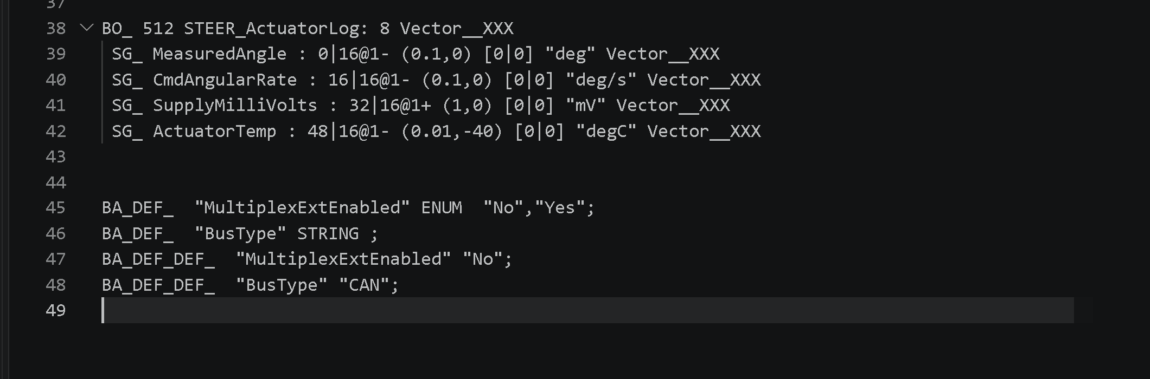
Line 38:
BO_ 512 STEER_ActuatorLog: 8 Vector__XXX

BO: This is a CAN Frame
512: This is the ID which identifies what the data is and its priority.
- Note: CAN ID’s are written in hexadecimals, so it is instead 0x200. Thus when reading log files, we must only look at the lines where the id 200 or 0x200.
STEER_Actuator: The name of the message frame
8: Payload length in bytes
Vector__XXX: transmitter node name which is the connected device that is sending a message frame onto the network of wires
Since the question asks for only u_commanded and y_measured, only lines 39 and 40 will be used:
SG_ MeasuredAngle : 0|16@1- (0.1,0) [0|0] "deg" Vector__XXX
SG_ CmdAngularRate : 16|16@1- (0.1,0) [0|0] "deg/s" Vector__XXX

SG_ MeasuredAngle & SG_ CmdAngularRate: These are signal names, y_measured and u_commanded respectively.
0|16 and 16|16: Starts at 0 and occupies 16 bits (2 bytes) which is a specified date value where such as a sensor begins at the very first bit and uses a total of 16 bits to store its value.
@1: Little endian which is a bye-ordering method from lowest to highest used by computers.
(0.1,0): This is the Factor to offset meaning where the factor is 0.1 and the offset is zero meaning. Thus the equation using these are shown as:
$$RealWorldvalue=Raw16bitvalue*factor+Offset.$$
Before we start writing the parser, we must look at the logs, which are the raw numerical data frames from the CAN Bus so we understand the format and what we are actually looking at before we create the actual analysis datasheets. Thus we will open Step_test.log.
Opening it gives a massive set of lines as shown below:
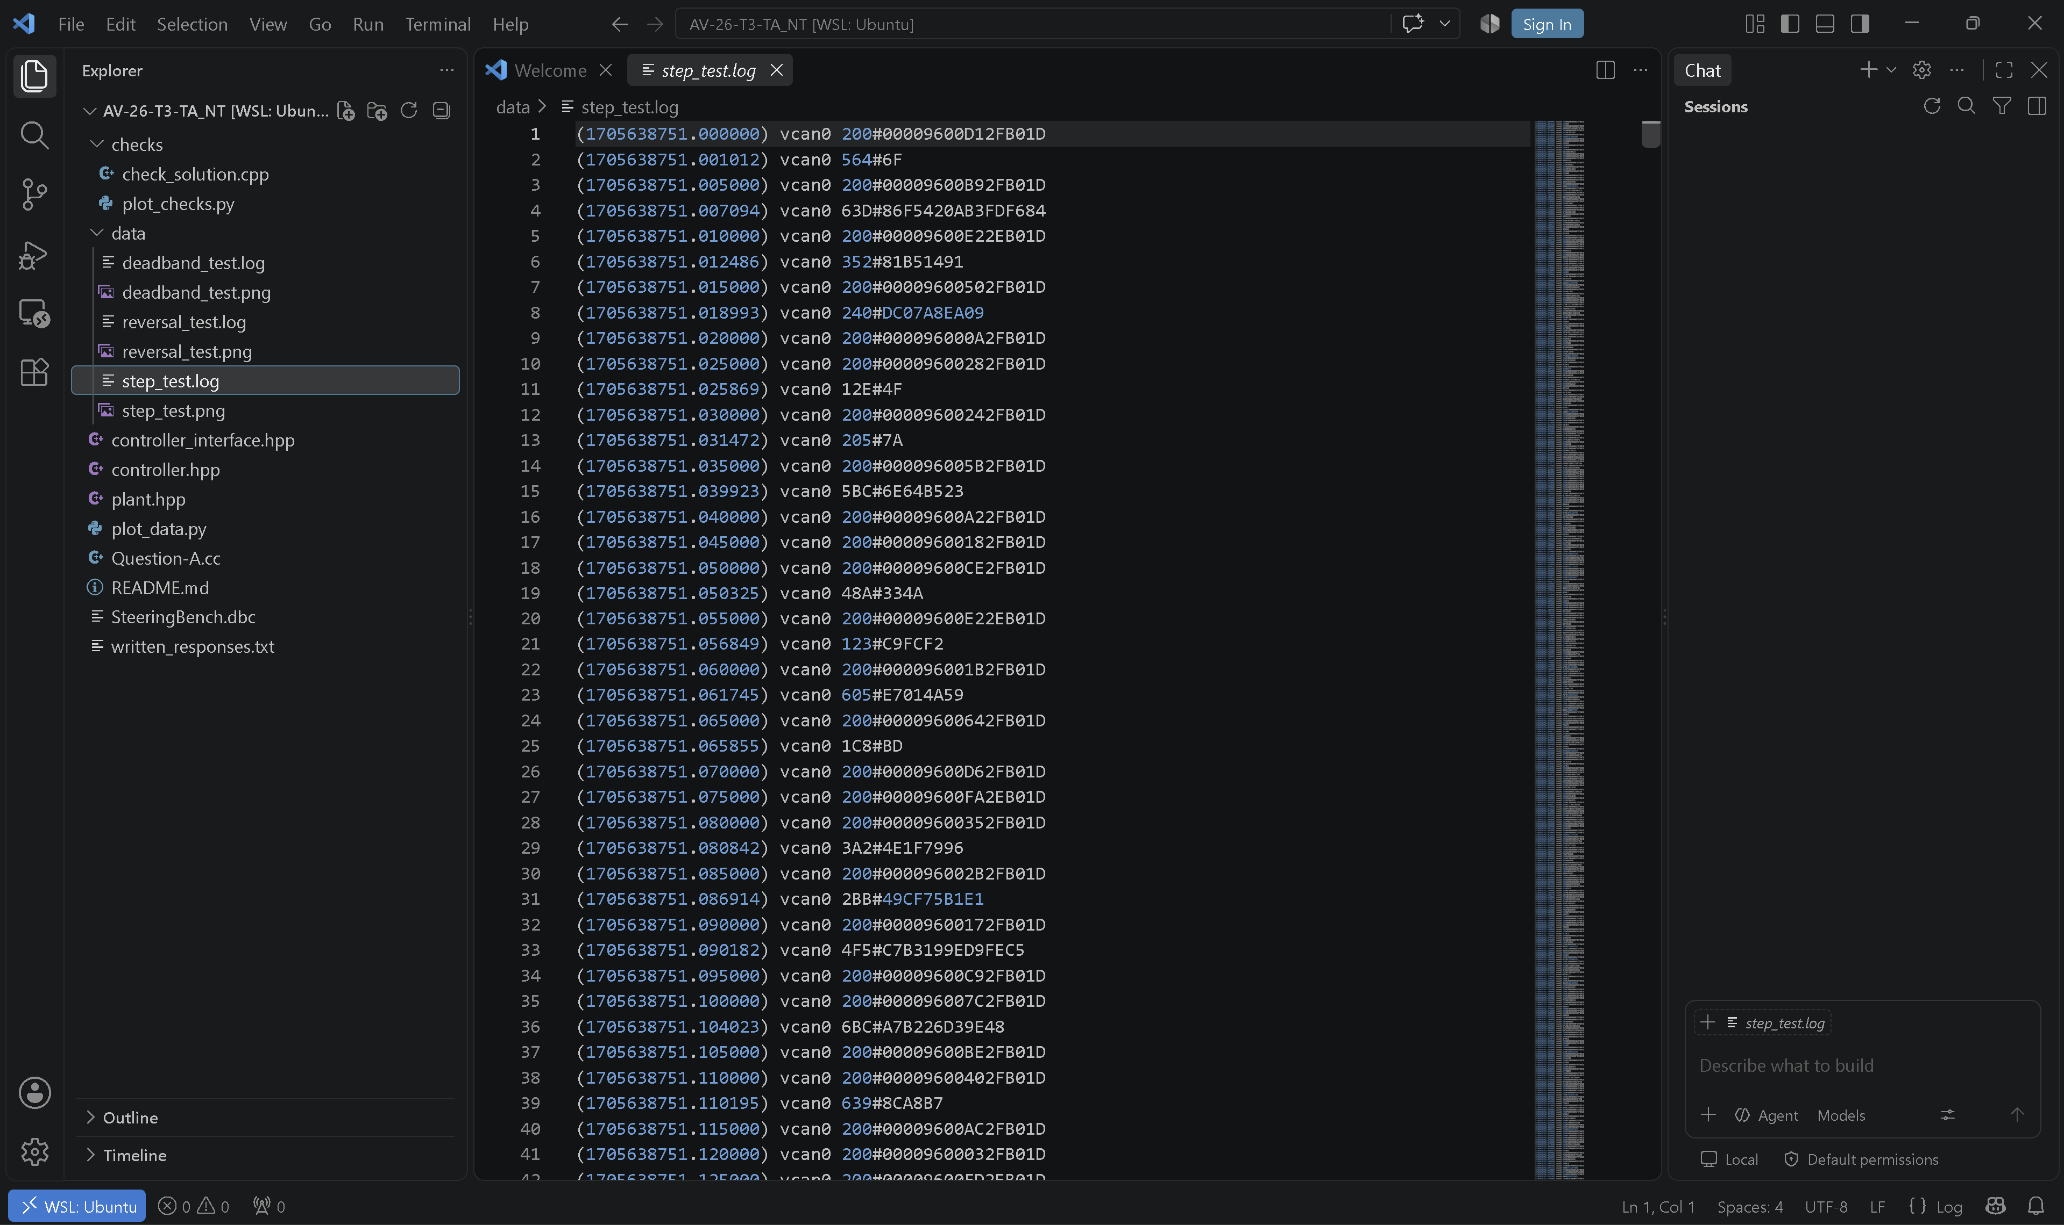
And the first line is analysed to gain an understanding of what is being parsed as shown below:
(1705638751.000000) vcan0 200#00009600D12FB01D

1705638751.000000: This is timestamp of when this was recorded for the CAN Message
Vcan0: Bus name (specifically Virtual network interface which allows testing of CAN application and simulate traffic on your local computer.
200: CAN ID (Important one!)
00009600D12FB01D: Hex data payload which is the encoded quantitative data of the component.

Importance Notice: The DBC File specified the message ID 512, which in hex is 200, this is why we check the DBC before the logs and parsing. Thus, ignore every line that doesn’t have the ID, 200.
Before we do the example, we must lay some thoughts out:
1 Bit = A single zero or 1
1 byte: 8 bits grouped together or two nibbles (4 bits)
1 hex character: (0 to 9, A to F): represents 4 bits
2 hex characters is 1 byte.

Example decoding of the quantitative data in a CAN Message, given:
(1705638751.000000) vcan0 200#00009600D12FB01D

First we must calculate the total amount of bits in the message, we know that each of these values (00009600D12FB01D) is one hex character, which represents 4 bits. Doing the math, there is 16 hex characters in total, thus multiplying by 4, there is 64 bits In total.
But computers group bits into bytes thus, 64 divided by 8 gives us 8 or 1 byte per 8 bits.
(Computer also start counting from 0!)
Thus the following table can be formed using the known hex characters as pairs or simply, 1 byte:
Hex Pair Index | Hex Pair | Bit range | Notation on bit range (Important!)
Byte 0 | 00 | 0 to 7 | Reads first 8 bits of message
Byte 1 | 00 | 8 to 15 | ..
Byte 2 | 96 | 16 to 23 | .
Byte 3 | 00 | 24 to 31 | .
Byte 4 | D1 | 32 to 39 | .
Byte 5 | 2F | 40 to 47 | .
Byte 6 | B0 | 48 to 55 | .
Byte 7 | 1D | 56 to 63 | .

Now we can go back to the DBC file. We see that Measured angle starts from bit 0 and goes up 16 bits, so we know that 0000 from the frame is known as Measured angle.
Furthemore, we know that the CmdAngularRate starts from bit 16 and goes up 16 bits, thus the hex string 9600 is known as CmdAngularRate.
Now we know the component names, we can calculate the quantitative value.
For Measured angle:
$$0000=0x0000=0*0.1+0=0 degrees$$
For CmdAngularRate:
Due to Little Endian, the lowest byte is sent first, thus 96 is the low byte and 00 is the high byte in the hex. But humans read big-endian, thus, the high byte comes first followed by the lower byte, thus 0x0096 is the hexdecimal.
The 0x indicates it’s a hexdecimal so it can be ignored.
It is read from right to left.
Thus $0096 = 6*16^0+9*16^1=150$
Now to convert it into degree form, the dbc factor and offset is used:
$$150*0.1+0=15.0 degrees!$$
Note: We know it is degrees because the DBC file specified it as “deg” as shown below
This matches with the example:
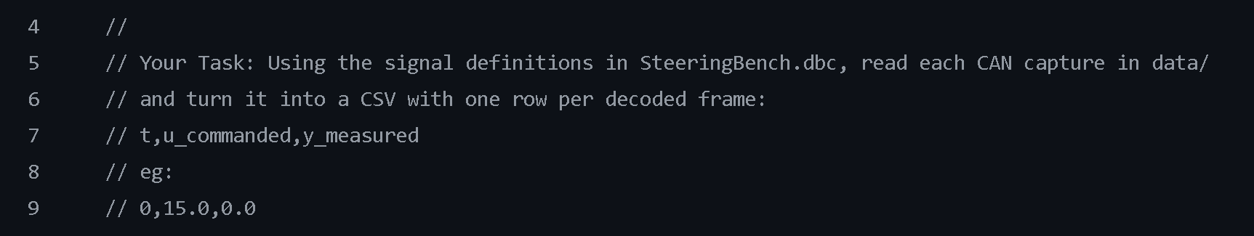
Note: The timestamp is 0 because it is the start of the testing of time elapsed.

Now the plan for the coding is written below for QA:
We first know that in lines 44-48, that when every line is decoded, the three values (time, rate and angle) is packaged into one row.
The text lines from the log files will be read line by line by opening a file stream which is a continuous sequence of bytes transferred to a file which allows the computer to analyse data piece by piece instead of loading to whole file to memory at once which would be slow so the following commands will be important:
Std∷ifstream: This inputs a file stream which allows the texts to be read and opened.
Std∷getline(file, line): Reads text character by character, saving the line into a std:;string variable
And so the next steps
2. Read line by line and skip lines which don’t have designated 200 number ID
3. Extract the important data which are timestamp, y_measured and u_commanded
4. Convert the little Endian hex bytes into numbers and apply the scaling and offset and save into rows.

Thus the code will be created here
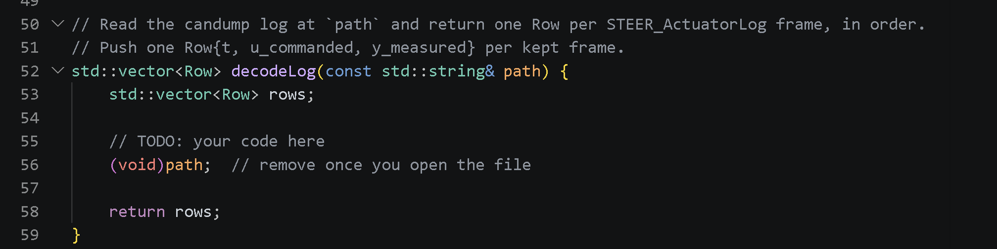
Note (std∷vector<Row> rows creates a dynamic array that can grow or shrink. This will be helpful when new rows are added for each decoded line of data.

Now lets start:
- a file stream is created to not cause data overloading when the data is being read, which will help not use a lot of RAM at once and crash the system as it reads data chunks at a time then the whole file. Then we must open it using path which will help analyse the data. Thus the following code is written:
(note: it is “std∷ifstream file(path);) (ifstream stands for an input file stream)
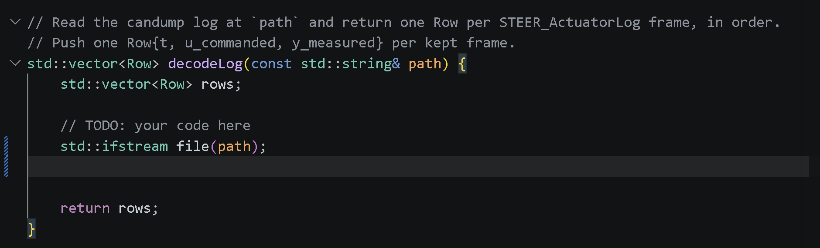
- Now the very first timestamp when the file is read, must be identified. The problem is, when the computer starts reading the log files, it doesn’t know the exact beginning timestamp. So setting it as zero would be not good. Thus, to get around this problem, we define the start of the time frame as a negative value as CAN Bus timestamps are always positive. Thus, this is a way of saying that the first timestamp hasn’t been recorded yet to ensure accuracy when analysing the actual data. Especially in motorsport, every second, every specific datapoint must be accurately displayed for optimisation. Thus we define it as:
(note: it is double time_start = -1.0;)
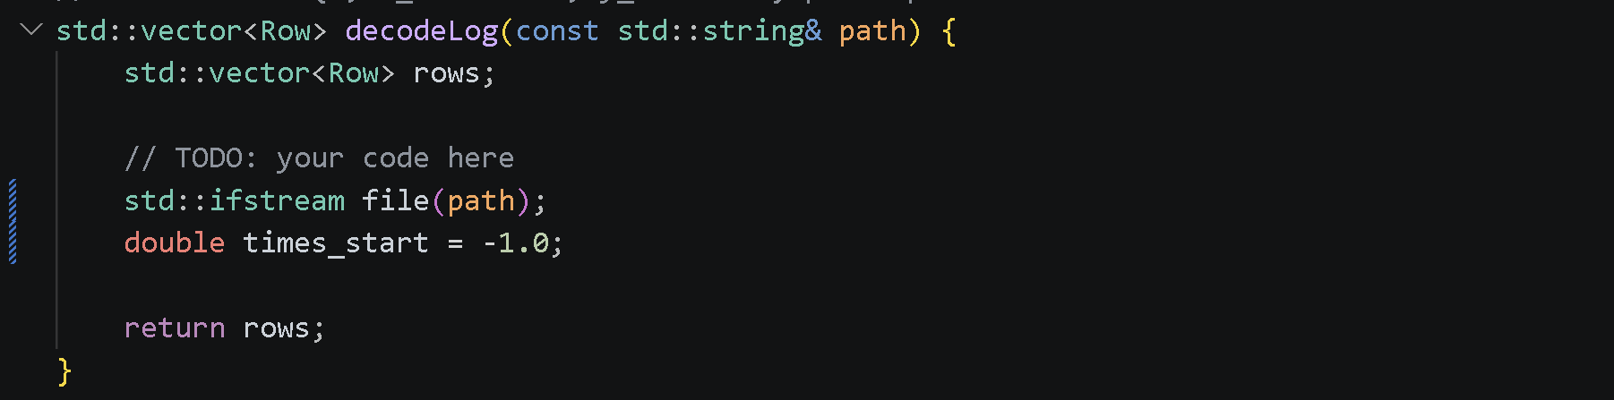
- Now we must iterate every line of the log file so it can read all the data points. Thus, a while loop is used and a text variable, named as “datastorage” is created so each iteration would store the data into datastorage. Additionally, the code, std∷getline allows the program to read the lines from the file one by one which helps gather the relevant data. Thus, the program is made below:
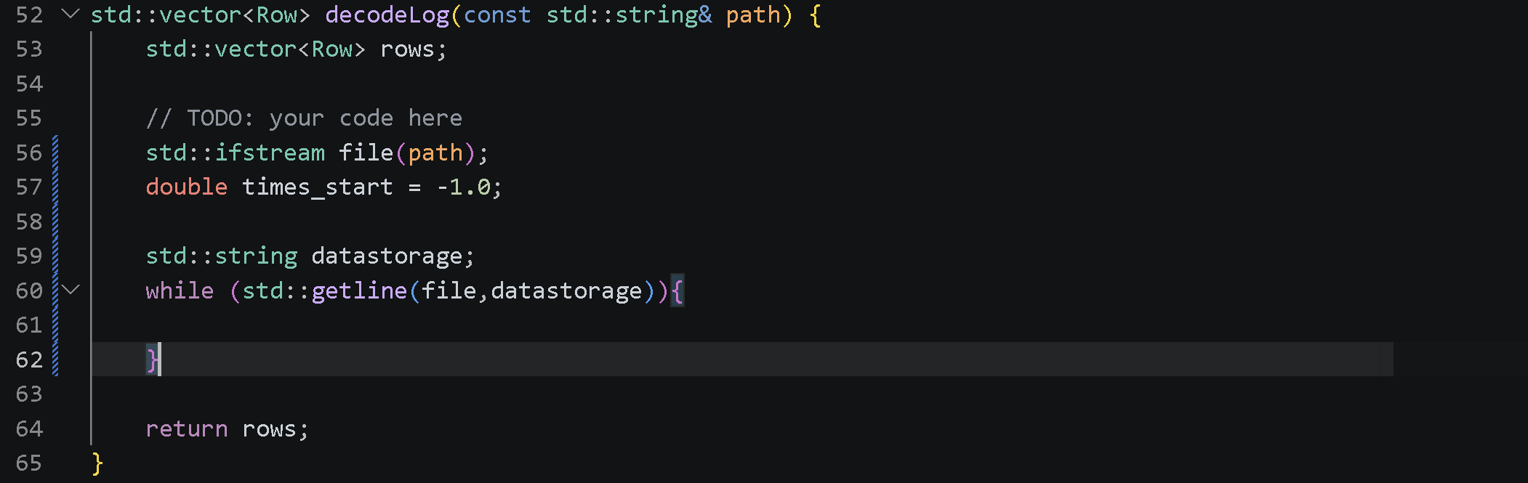
- To actually read the file properly, the DBC file told us that the ID is 200, meaning once the file starts being read, we only want to collate data from the lines which have this specific ID. So an efficient filter must be coded. This is through using the .find function which literally reads the files to find the correct data with the correct ID. The problem is, if it encounters an error, the program would break, so to fix this, an if statement and npos (which in c++ represents an invalid position) is used with a continue statement so the while loop can keep on running whilst ignoring the wrong ones.
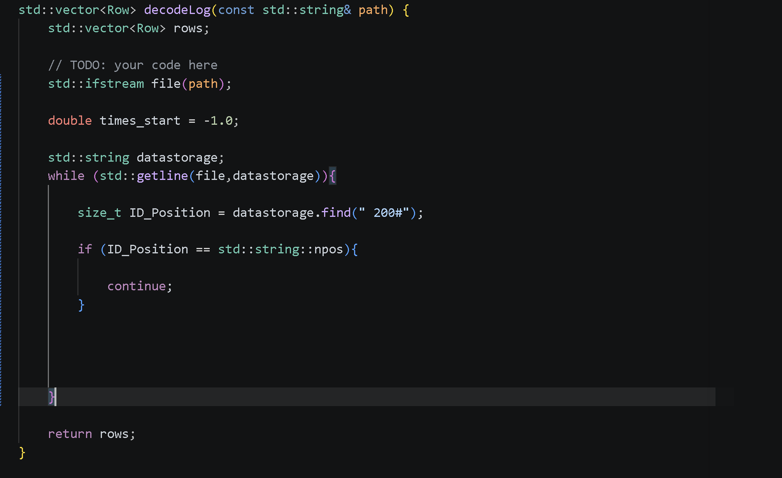
Note: (Another problem has been encountered on this journey. An int can only store so many bytes (negative to positive) and thus if a file is encountered with lets say, one extra byte over the limit, it will cause an interger overflow and boom, an error. So to solve this, size_t is used which is unassigned, thus has no negatives which is also relevant to the timestamps which are only positives. Furthermore, will prevent these overflows and errors when counting the positions of the logs.
- Now we can identify the ID, we must now actually get the data from the logs, aka, the timestamp, y_measured and u_commanded. This can be done by cutting the string in the logs into segments by finding the barriers for each and slicing them. Thus we will use .find to find the brackets that the timestamp is contained in and extract whatever is within the brackets. Additionally, using some arithmetic’s to slice the rest of the rows to get our needed information using the .substr function to extract it and std∷stod to convert it to a float because it is a numerical value we will use for the data analysis.
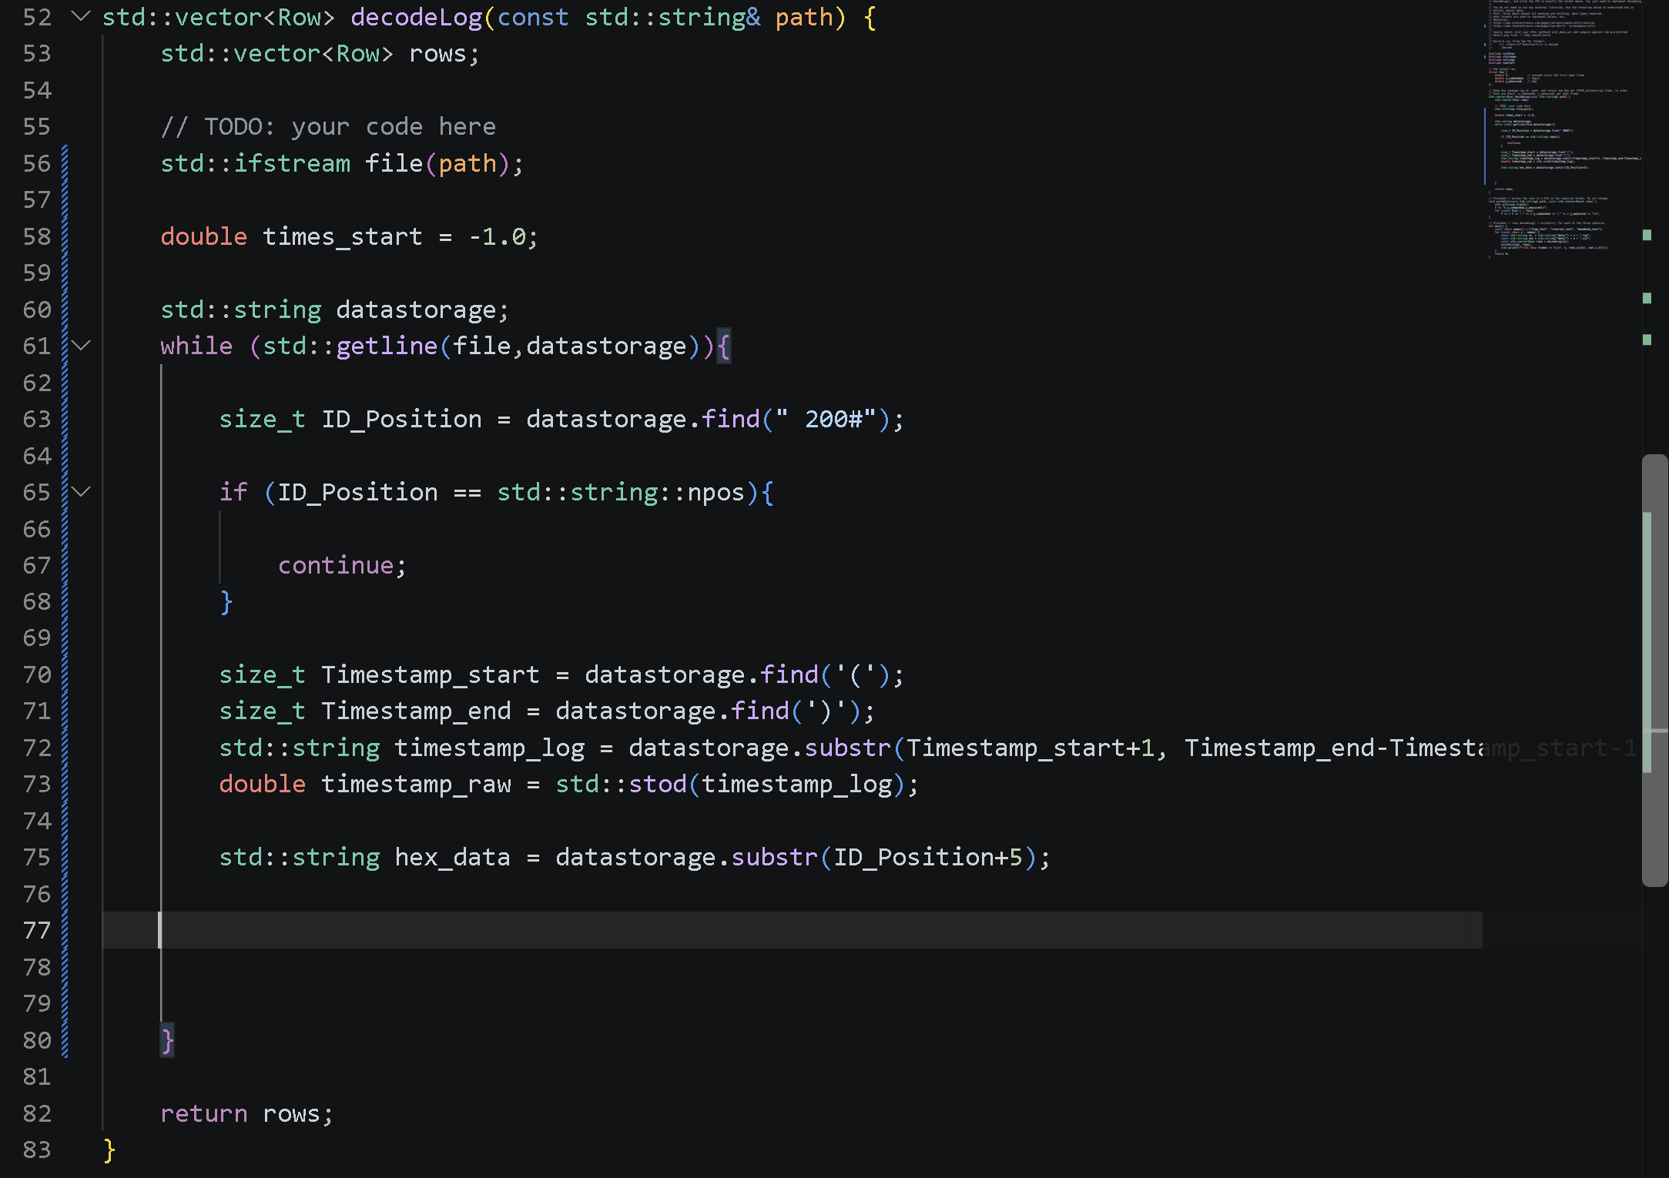
Note: Timestamp_Start + 1 makes it so we begin in the actual timestamp and not the bracket. The subtraction operation in the right of it, ensures that the length of the timestamp is calculated so the full timestamp can be read and extracted. ID_position+5 makes it so the program reads it at the very start of the hex-decimal (because the ID position is 5 characters long, and starting from 0, adding 5 would place the reader in the first hex-decimal which is right after the ID).
This was done instead of just hard-coding the position to ensure any fluctuations in the position can remain steady.

- Find the start time stamp:
Now we have the raw timestamp data, we can actually find the very first timestamp of the ID 200# and then use that to find the rest of the timestamp data points relative to the start. This is by using the earlier variable of time_start = -1.0 and an if statement that executes only ONCE. This makes it so that when it detects the first timestamp in timestamp_raw, it will update the time_start to it.
Then, the rest of the timestamps can be found via the formula coded below:
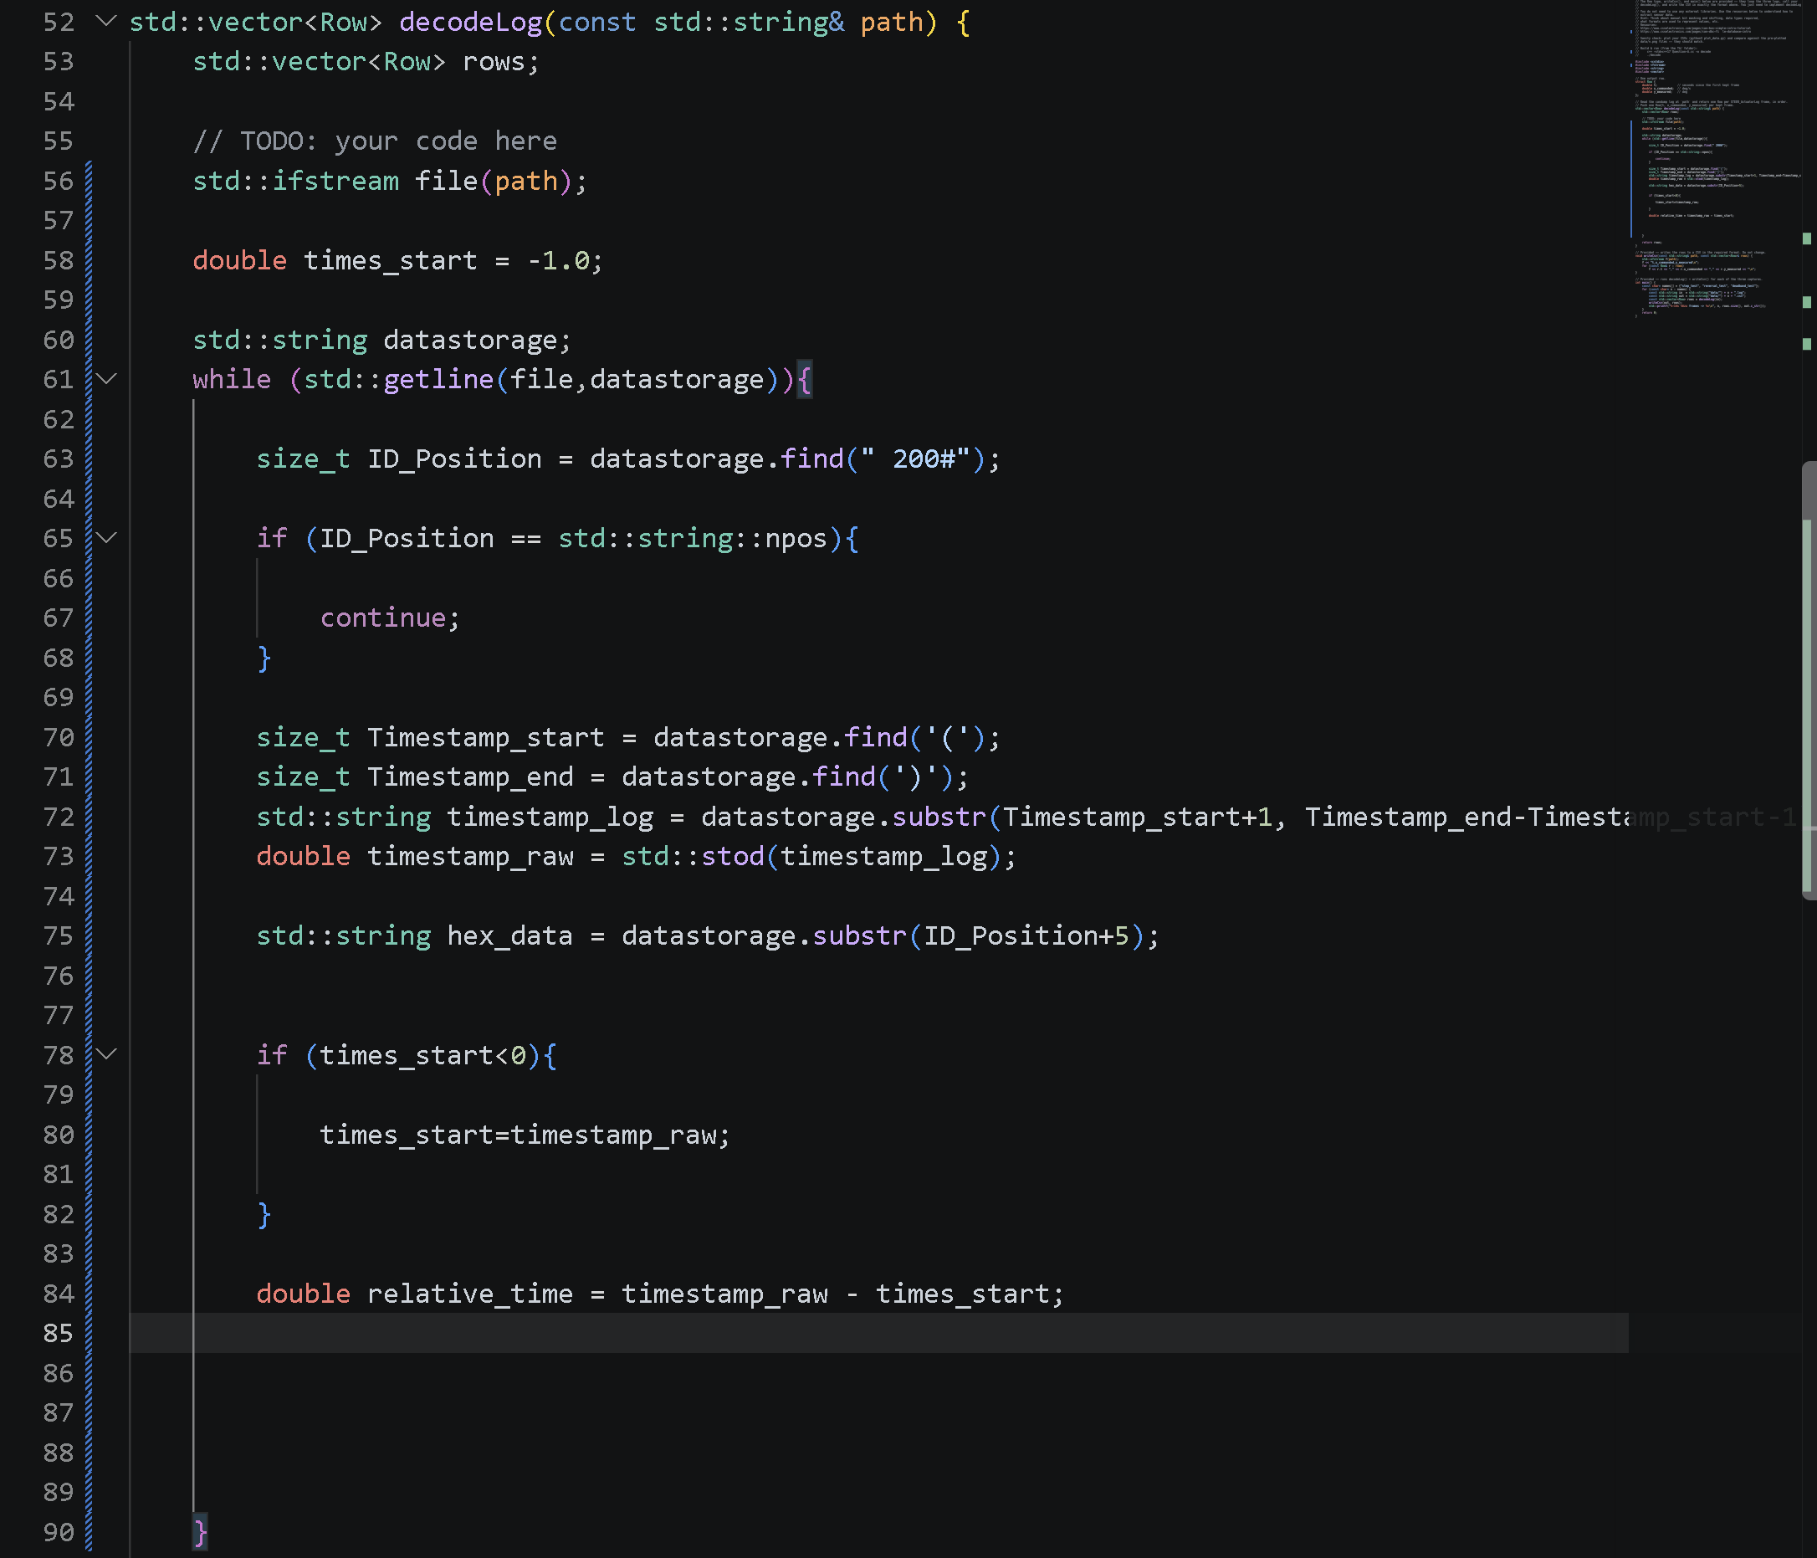
Note: The if statement only executes once!

- Extract u_commanded and y_measured:
Now we have our timestamps, we can extract the two key datapoints, u_commanded and y_measured. To do this, we must tell the computer how much characters it must count and collect. This will be doing by using substr(start,counted characters) inside hex_data. But due to Little Endian format, this must be reversed as human readings go from high to low byte as most modern computers use little-endian natively. So this will be applied.
After getting the relevant hex pairs, it must be converted to a proper signed integer so it can be multiplied and off-setted to find the actual angle using arithmetic expressions and std:stoii. So these steps are followed and programmed for u_commanded and y_measured.
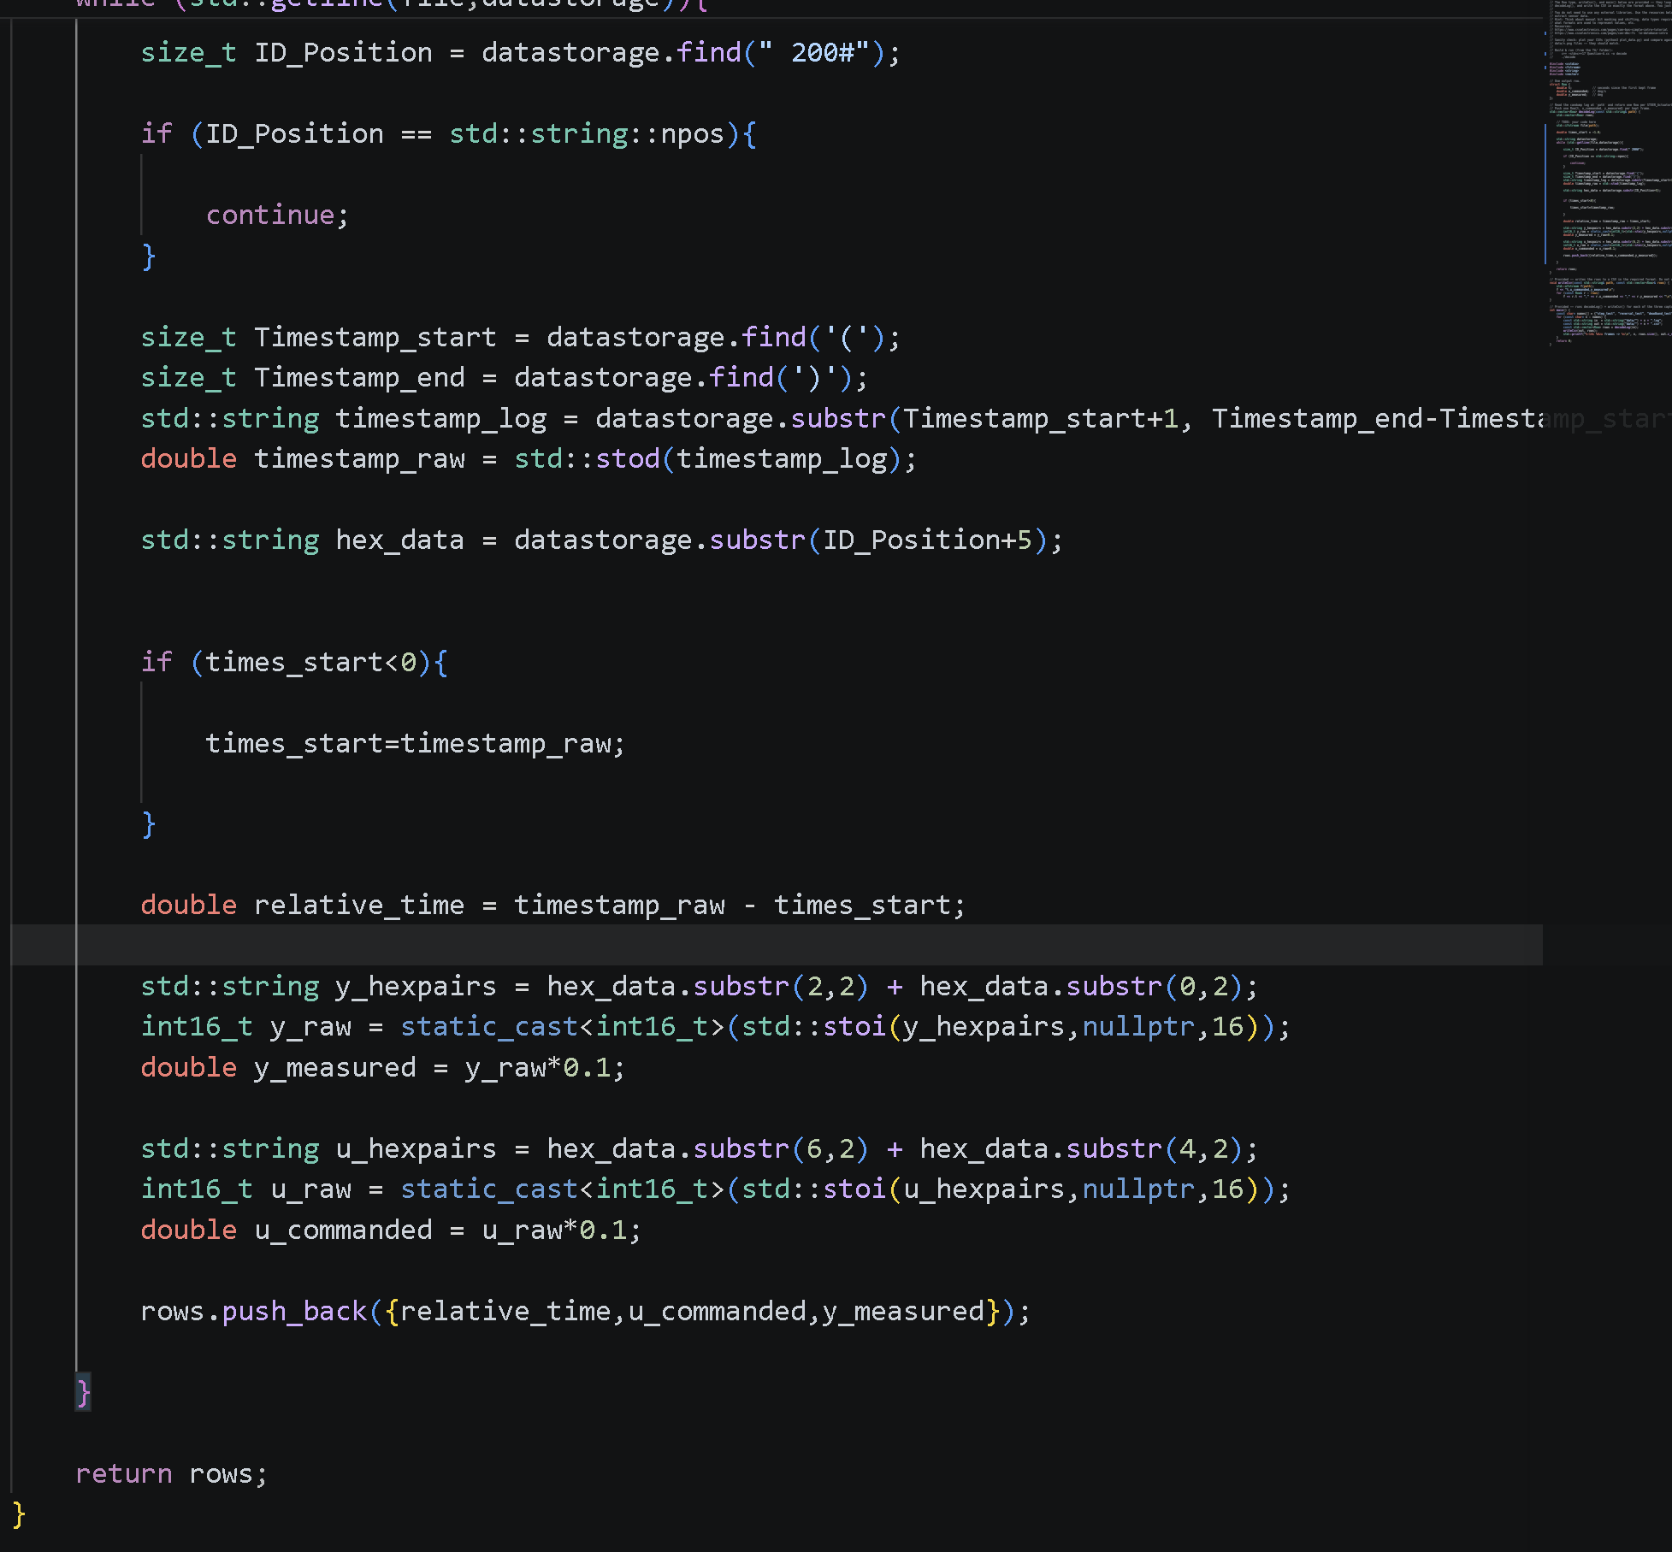
Note: The 2nd last command, the push back allows the new data to be pushed to the end of the list, or the new line, creating a nice clean list of data.
Note: A problem encountered in this section is trying to get the data down into a 16 bit (because the actual value is given in 16 bit such as 0096). container as the computer automatically puts the steering data into 32 bit (which is int). To resolve this, static_cast is applied with int16_t which says to store the data in 16 bit, assuring a clean transfer. Null ptr is also used to prevent any unnecessary parsing metadata (like telling that it doesn’t need the note that the program stop reading at a certain position within the hexdecimal).

- Time to test!:
To test this, the we open the VS code terminal and input the commands:
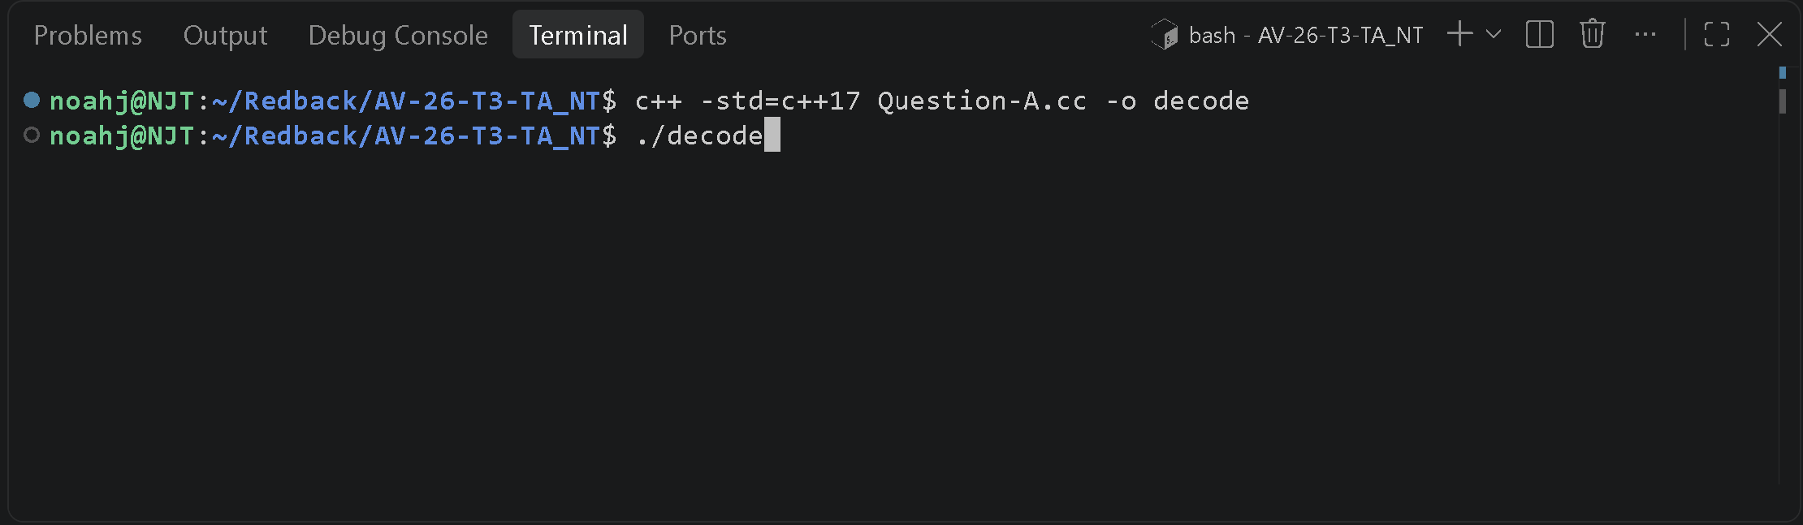
- Success!:
It worked!
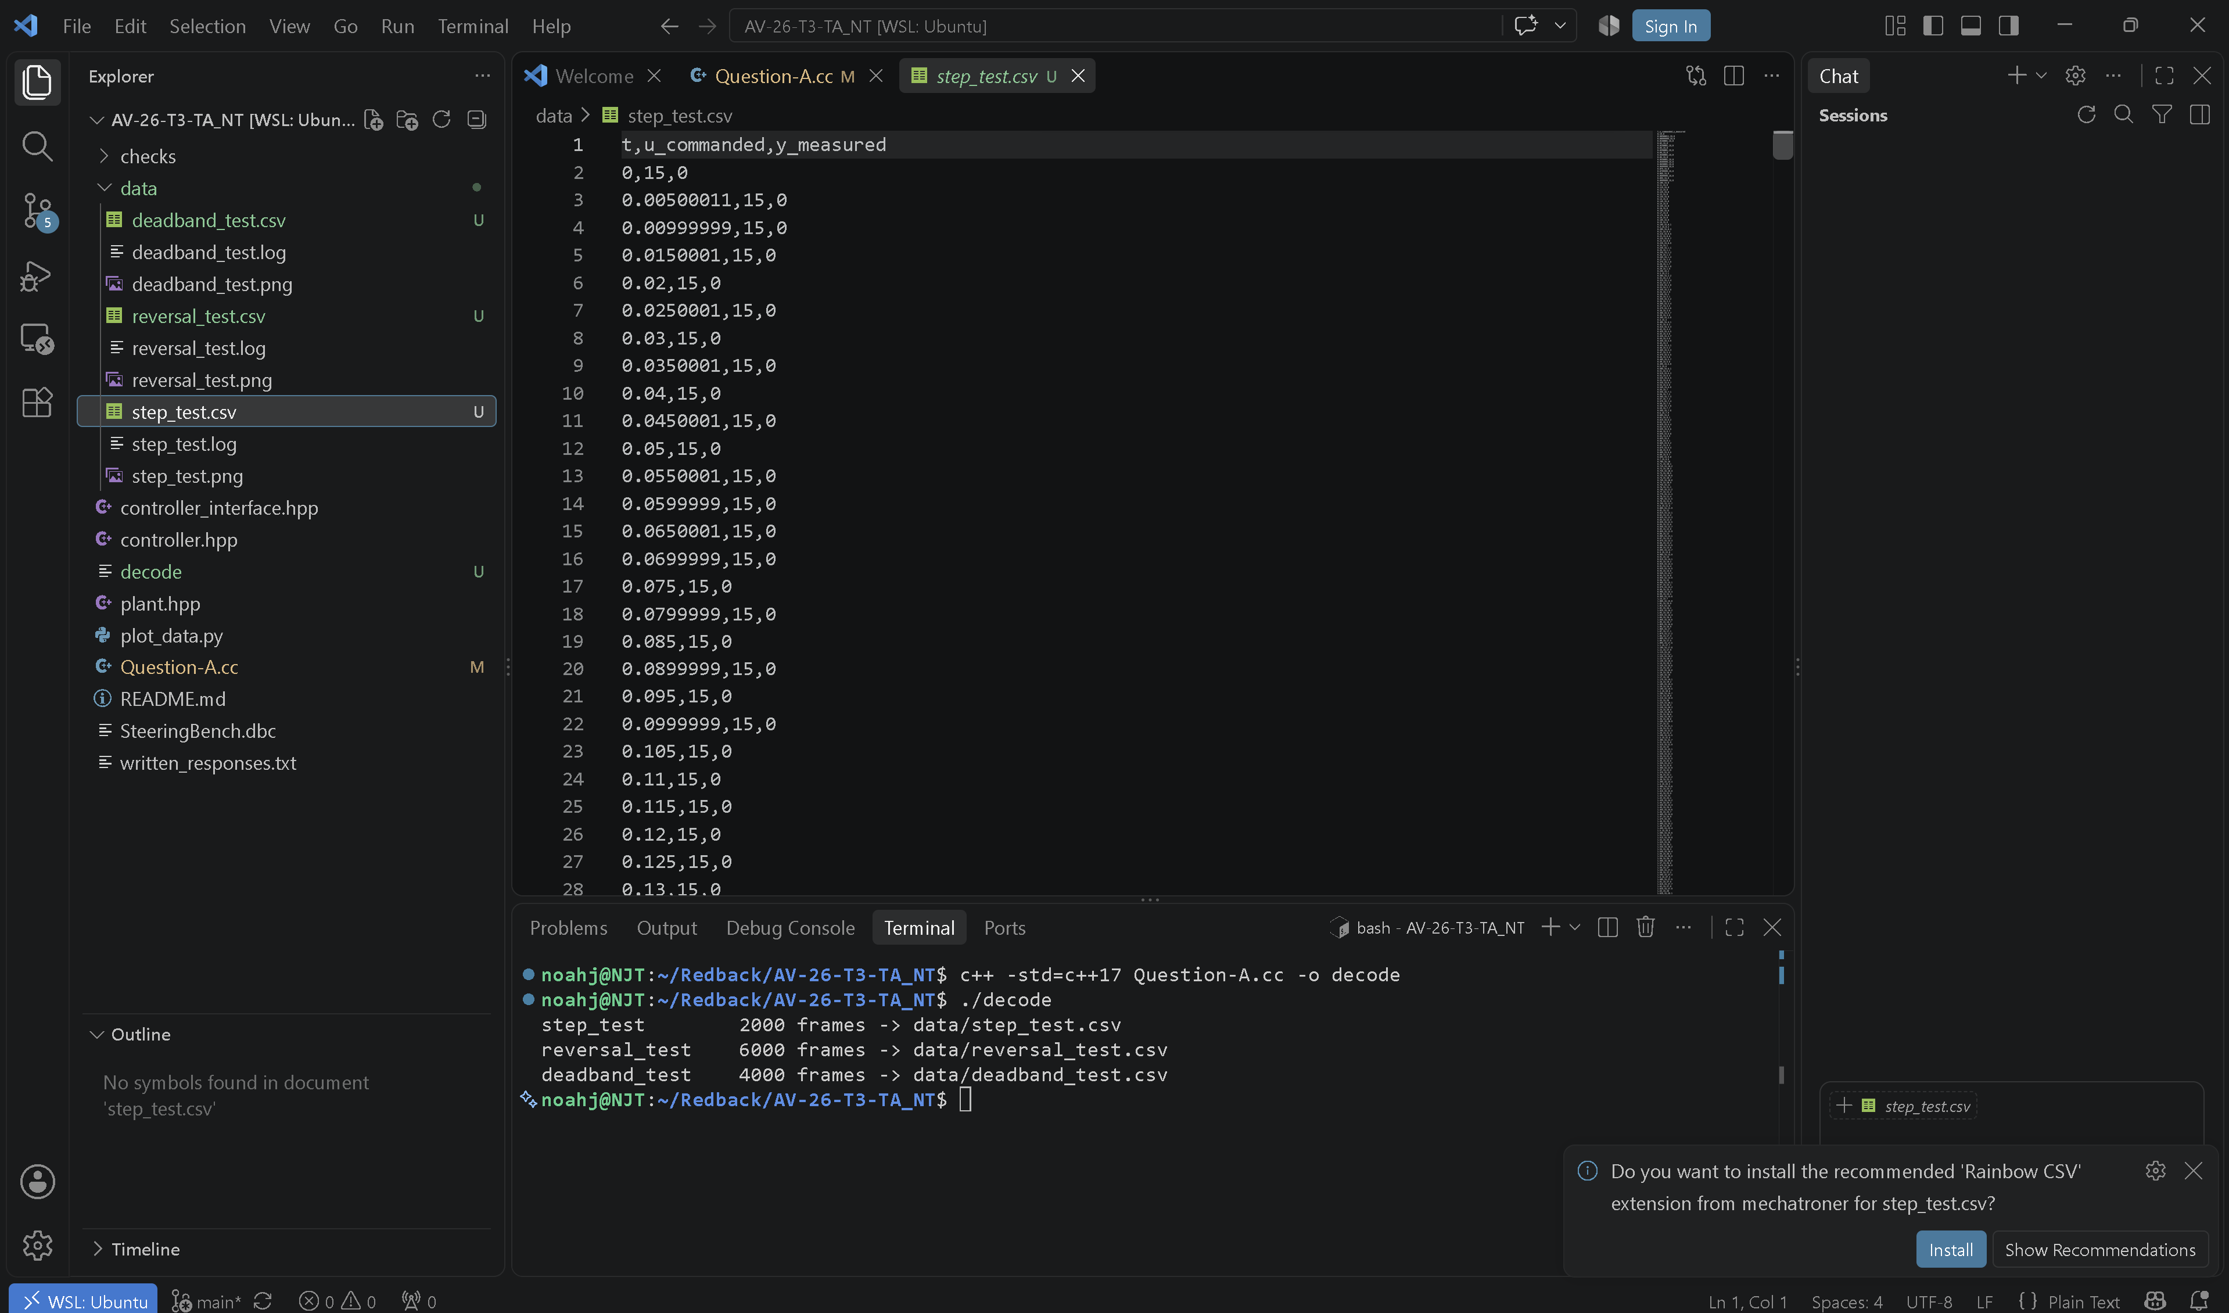

Part B: Identify controller behaviour
To identify the controller behaviours, the created .csv file must be converted into a readable graph which will help assist in analysing the data.
A problem was encountered during this process. In plot_data.py, I completed missed the need to add –save at the end of the python3 plot_data.py command. This was a significant error because by missing this flag, the action was false and thus failed to create a PNG with my data which also skipped the if statement of args.save and thus failed to create a brand new png with my data. Thus came with this error:
/home/noahj/Redback/AV-26-T3-TA_NT/plot_data.py:85: UserWarning: FigureCanvasAgg is non-interactive, and thus cannot be shown
plt.show().
The success is as shown below:
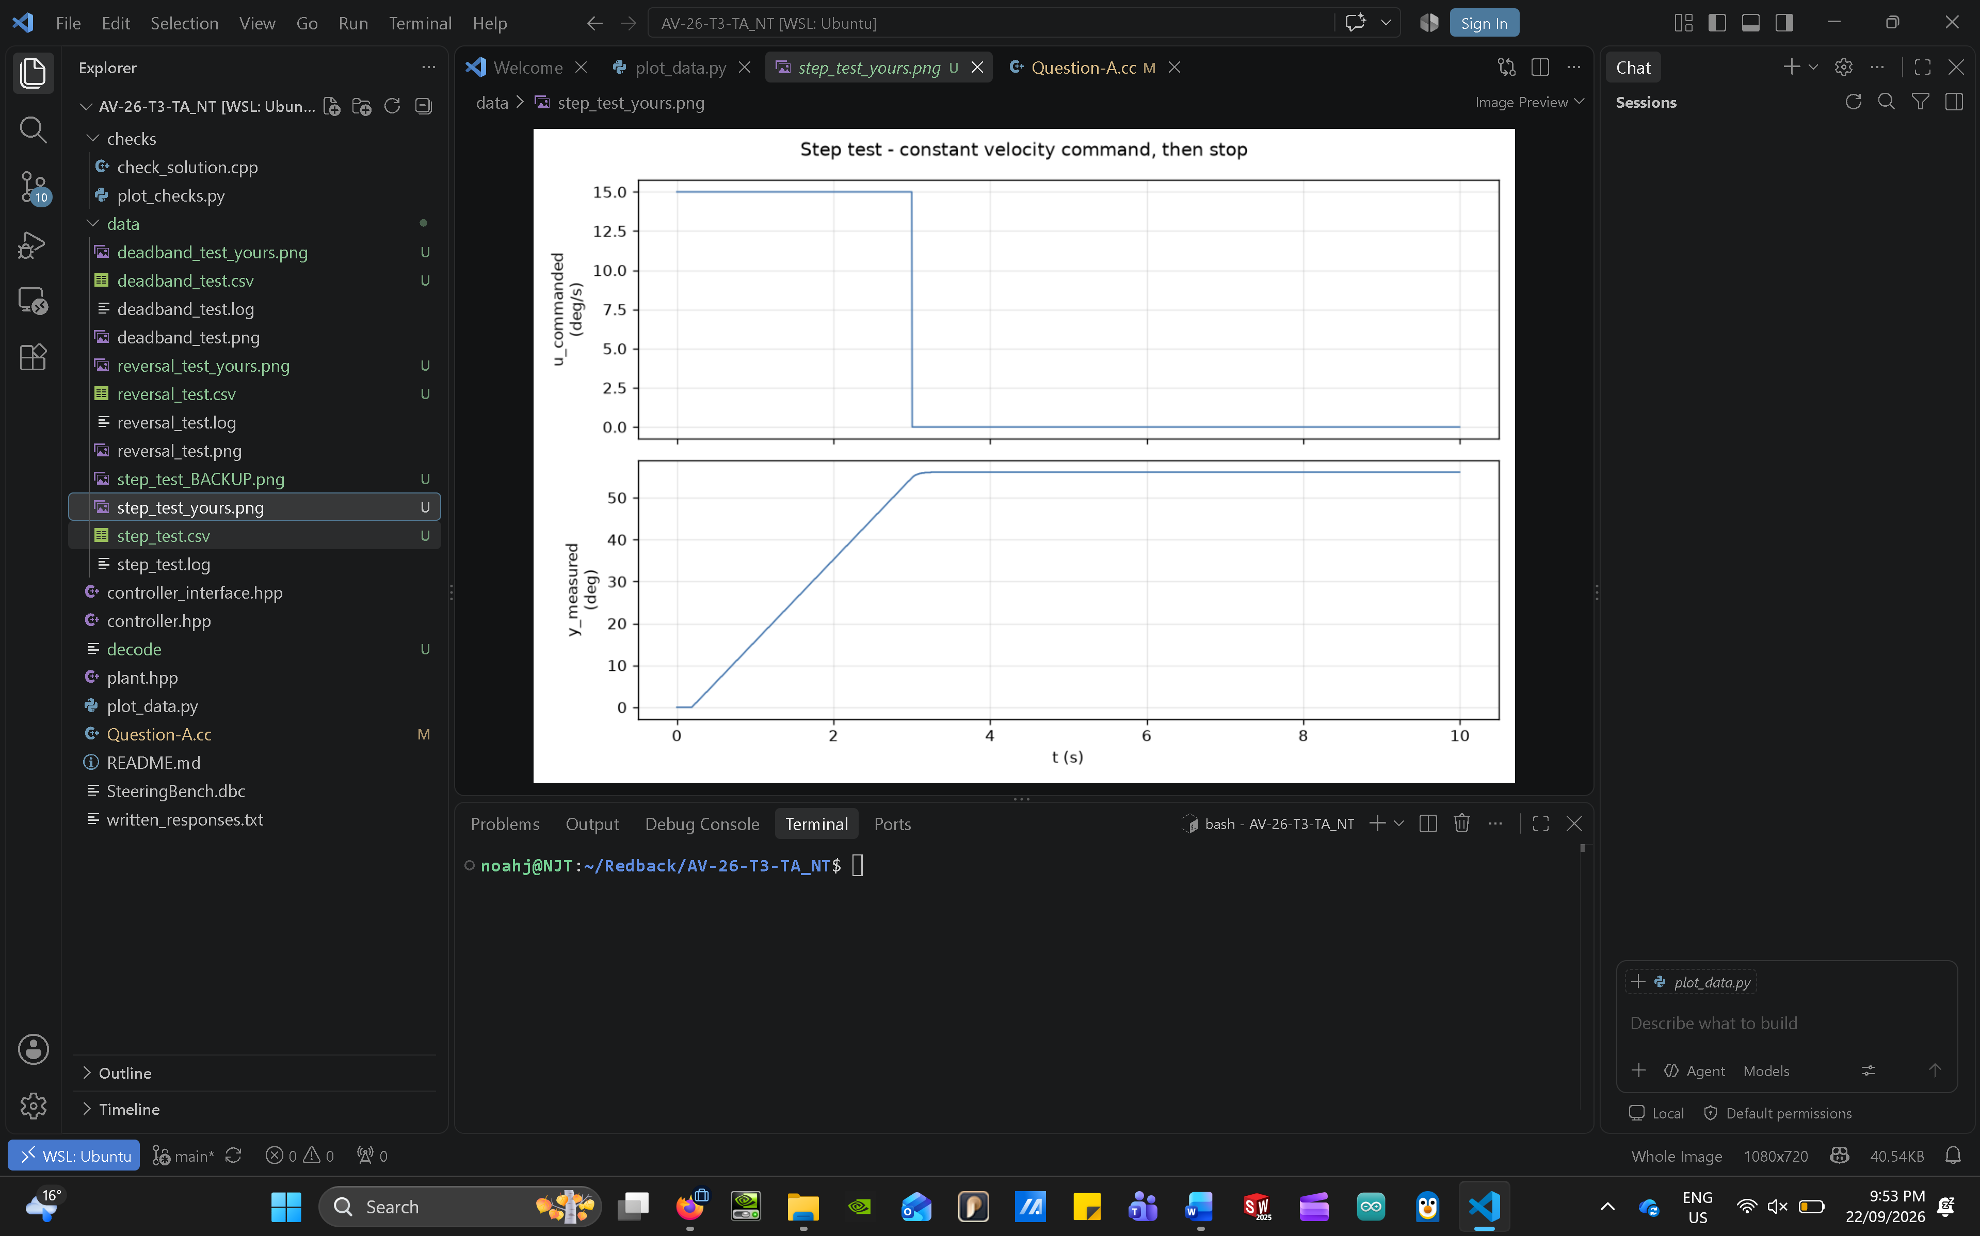

Now the problem is fixed and my data has been stored successfully into a png, we need a mathematical formula to map out the physical system and how it responds to commands such as the velocity which makes the hardware go to a certain position.

The tasks specify that the plant is a first-order system. Thus it follows the mathematical formula of
$$τ*(dy(t)/dt) + y(t) = K*u(t)$$
This is where:
$τ$ or tau is the time constant, which shows how fast the system responds to change in input (like a lag constant).
y(t) is the measured output in degrees
u(t) is the commanded input signal in deg/s
K is the system gain that measures how strongly a system reacts to an input by dividing the final change of output to the change of input once the system settles.
Note: Steady state is when the outputs stop fluctuating and remains constant.
Tau and K are the targets to be identified. This is because it finds the lag in the system and sensitivity in motors (scale factor) respectively which provides a nice baseline for later stages in programming and tuning the actual actuators.
First we will find the plant’s gains:
This is very important because identifying the value of gain will give us insight on whether the system is moving faster or slower than commanded so we can later on program the correct PID loops.
The Gain (K) formula is given by, as stated earlier:
$$K=\frac{final change in output of the measurued steady-state velocity}{final change in commanded velocity}$$
Now we will look at the graph:
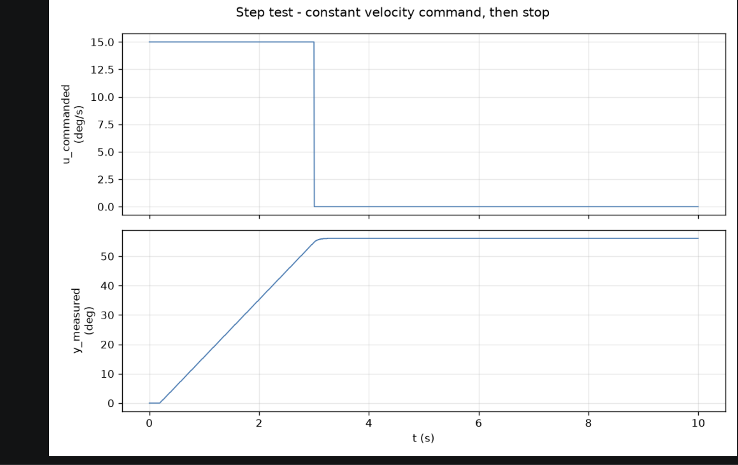
Finding y_measured:
From the bottom graph of the figure above, we can see that approximately from 0 to 0.19 (in referenced to the .csv file for step_test), there is a small plateau. This is normally due to delays or start-up once the system is activated, so we can ignore this.
The actual data lies in between an approximately 0.195 to 3.245 seconds range. This range represents a continuous linear line increasing from 0.1 to 56.1 degrees. This is used because a constant slope proves that there is zero acceleration in the actuator and it is changing position at a steady predictable velocity.
So the following data points are collected for y_measured:
0.195 seconds has a degrees of 0.1
3.245 seconds has a degrees of 56.1
Thus:
$$y_measured = \frac{change in degrees }{change in time}$$
$$= \frac{56.1 - 0.1 deg}{3.245 - 0.195 s}$$
$$18.3606557377 deg/s$$
Note: We do this because we need a steady state value to divide by the input to find the K value as position constantly changes within that timeframe.
Finding u_commanded:
According to the to the top graph in the figure above, in the time frame, the u_commanded fires a constant velocity of +15 deg/s from 0 deg/s (from off to activation). This results in the change of it being +15 deg/s.
Note: This is held for approximately 3 seconds before being turned off back to 0 as shown by the sudden spike drop at around 3 seconds. This window-frame provides a steady input of velocity for the actuator to reach steady state.

Finding K:
Using these found values, the following is calculated:
$$K=\frac{18.3606557377 deg/s}{15 deg/s}$$
$$K =1.22404371585$$
Thus a K value of 1.22404371585 is estimated. A k value of 1.22 sits comfortably above 1 which means that the actuator is overly sensitive and reacts to tiny changes, this is a problem when trying to maintain steady state.
Finding tau:
Tau must be calculated because its represents the motors responsiveness to the signal, either its sluggish or fast. To find tau from a position graph, we must take the idealistic degrees covered across the steady state period of 3.245 seconds and subtract it by the actual final amount it has reached in that time frame:
Idealistic with zero leg:
$$3.245 s * 18.3606557377=59.58 deg$$
Realistic: The realistic degrees achieved was 56.1 deg
Now, subtracting the idealistic from realistic, we get 3.48 deg is lost due to a possible delay in the initial phase of acceleration at the start.
Now to find tau, the time of lag, the degrees lost would be divided by the average steady state velocity (the distance, time, speed triangle!):
$$time (tau) = \frac{3.48}{18.3606557377}$$
$$tau = 0.1895 sec$$

Now K and tau is found. We must identify how the motor behaves near zero commanded rate, such as when a car is starting up/during the beginning states of driving. This is significant because the K and tau value were calculated from linear models which respond to every input proportionally, but in the real world, everything has some type of resistance or friction, thus deadzone/backlash must be considered as they are real factors that cause these issues. To do this, we can find non linearities which are deadzone and backlash.
Deadzone is the idea that when a tiny input or command is given to the motor, it will often ignore this command because it must surpass a certain force threshold.
Backlash is the tiny opening or space, a gear or motors has when something is turned. This is basically a slight delay that occurs before the vehicle actually changes direction or the gear start turning.
So we want to identify whether it is; a hardware friction issue or a mechanical issue.
Thus the graph of the deadband_test was analysed below:
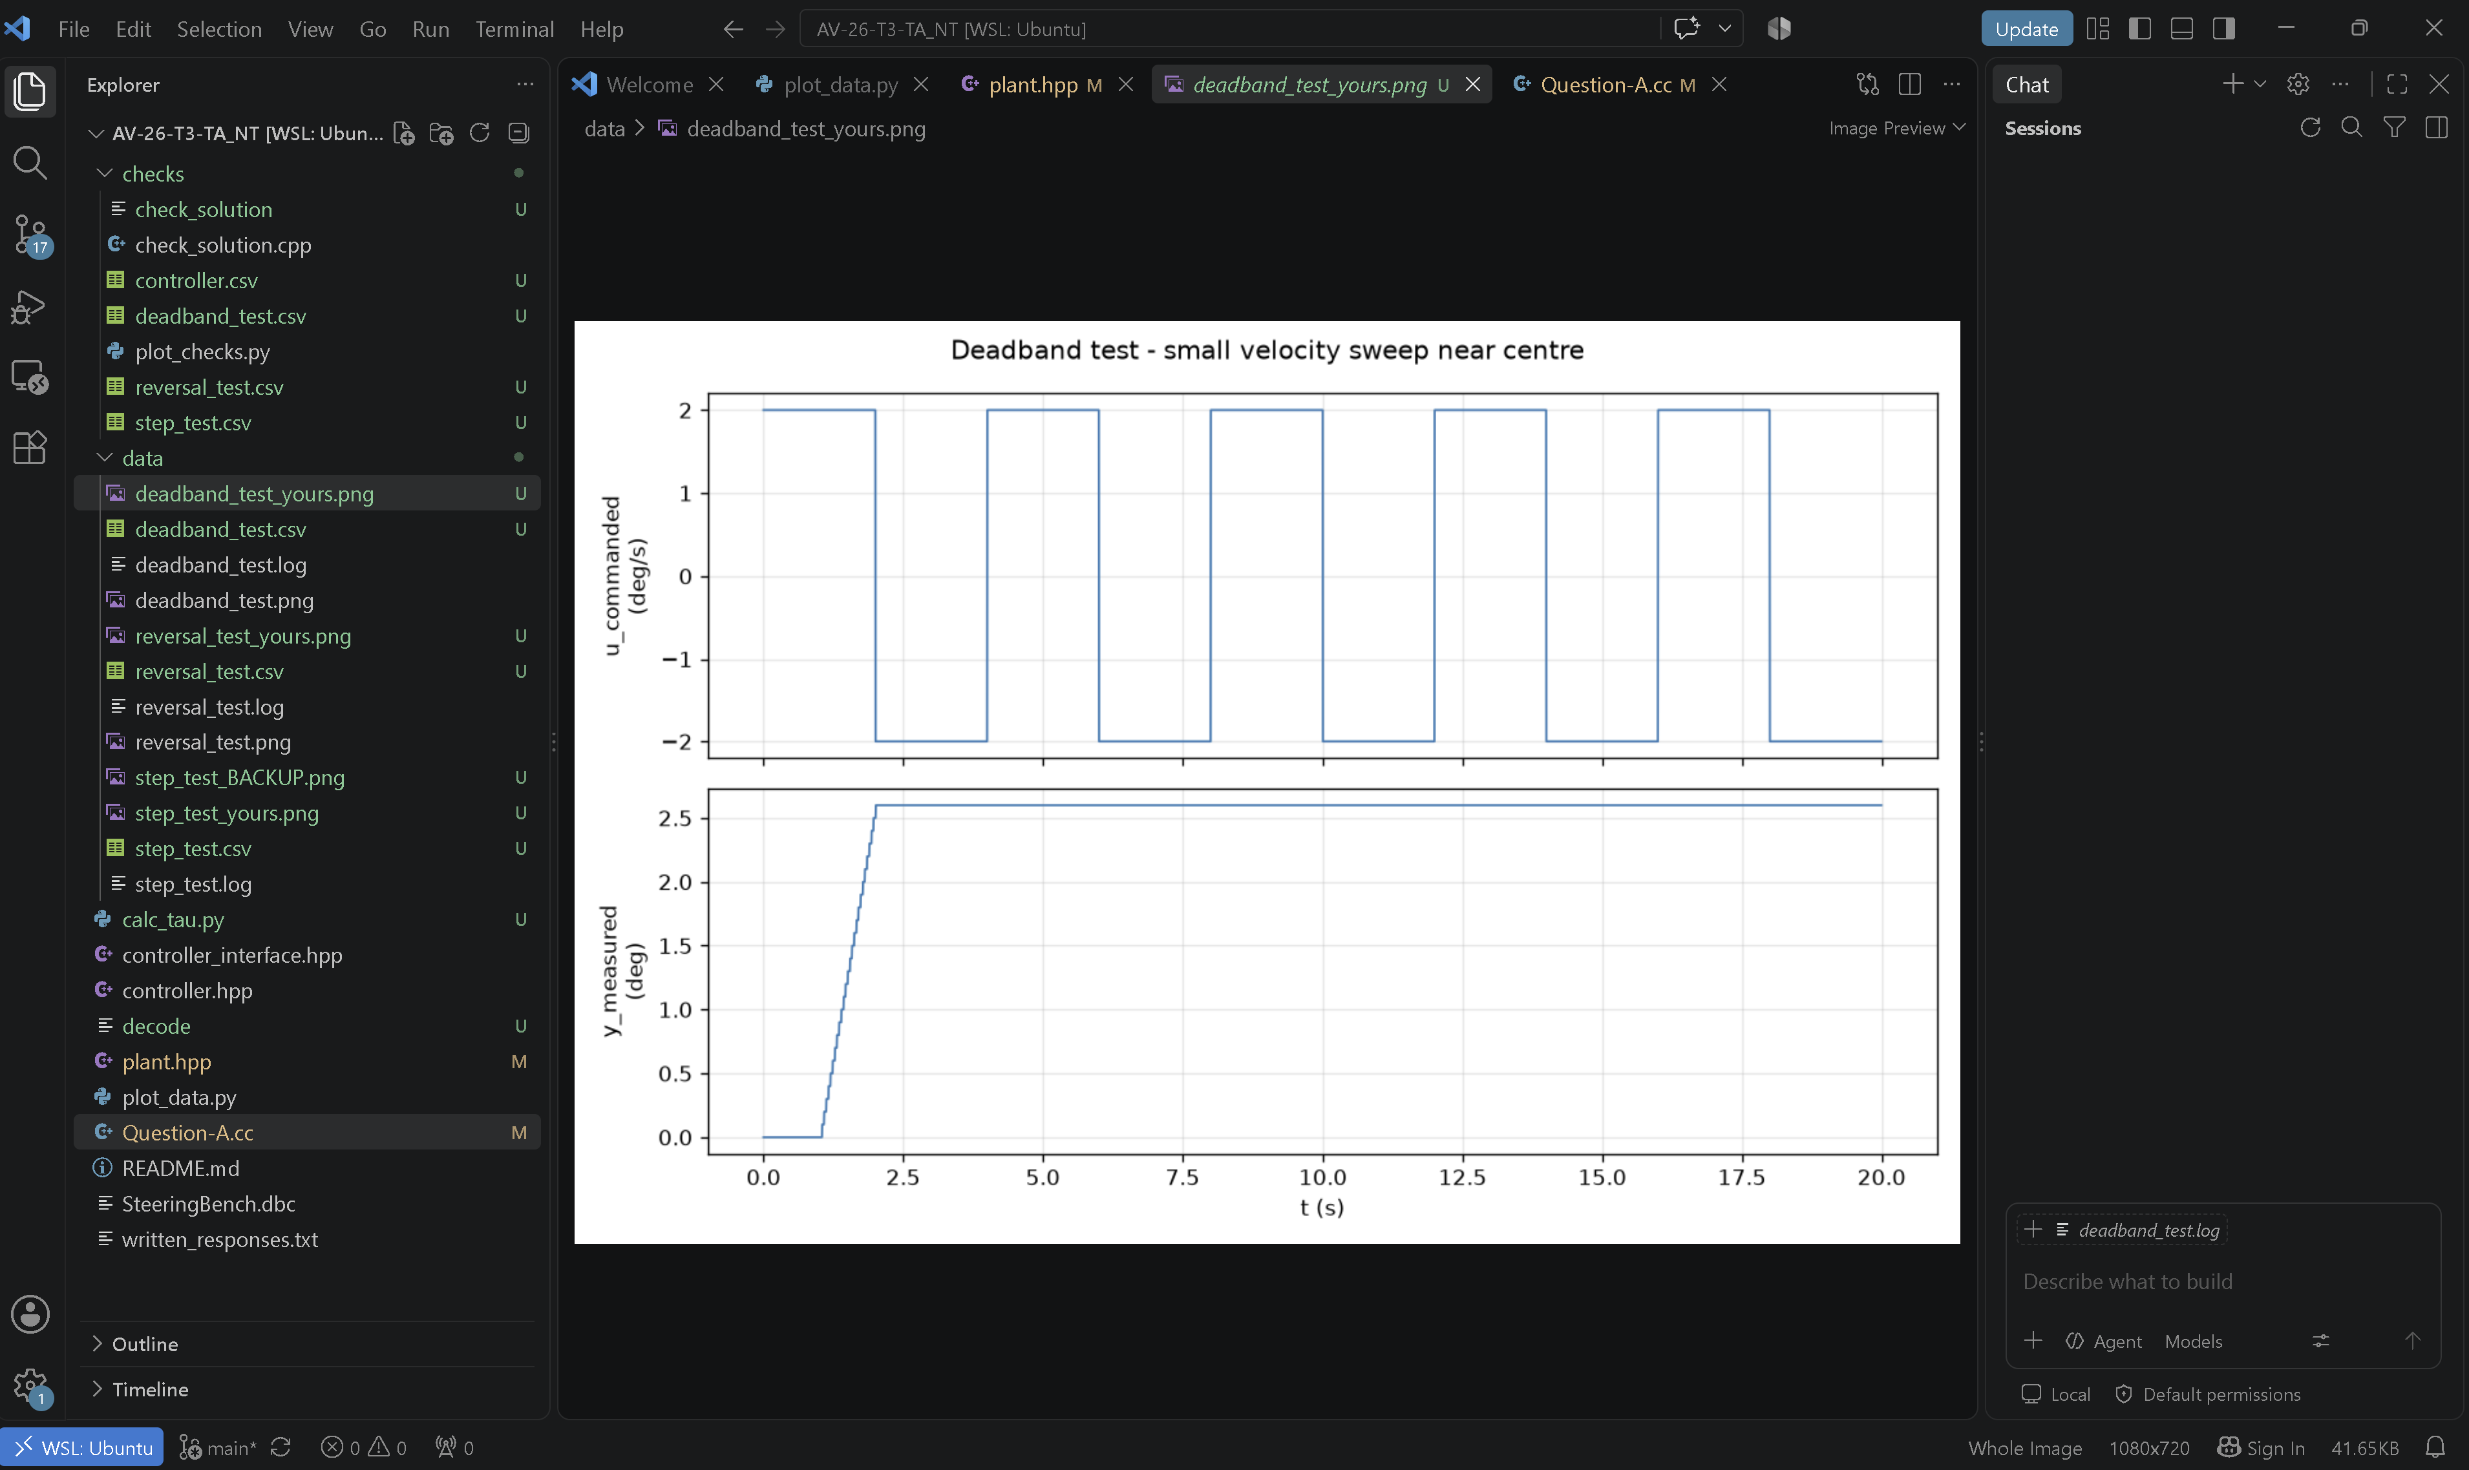

As we can see from the deadband_test, this is a clear representation of a deadzone. The top plot represented the commanded input overtime. The graph shows, where every 2 seconds as found in the .csv logs, there is a sharp aggressive drop in the value, going from 2 deg/s per second to -2 deg/s. This pattern follows every 2 second interval. This command hovers around the 0 deg/s mark producing a square-wave shaped graph. Consequently, in the graph below, which represents the output measured in degrees as a result of the command input (top graph), shows a sharp increase from 1.05 seconds to 2.01 seconds which changes the degree angle from 0.1 deg to 2.6 deg before flatlining for the rest of the time from 2.01 to 20 seconds, holding it at a steady 2.6 degrees. This shows that once the input was started, the output didn’t change which signified a particular deadzone within the motor, a threshold where the motor doesn’t respond when a certain amount of input is given.
Note: This isn’t backlash because if it was, the output would have received signals and jump up and down, just more sluggishly along with the input due to the delay, but still would have received and executed the command.

Now the graph has been identified as a deadzone, the size of this deadzone must be found. This is it provides an estimated limit of the force from the command before a vehicle actually does the action.
By observing the top graph above, we can approximate the deadzone using the input. Thus based on this data, we can see that from 2 to -2 deg/s of input, the output is stagnated and doesn’t change. Thus we can assume that the threshold for the deadzone is ±2deg/s.
Note: We are not actually sure whether the output will remain static past 2 deg/s, so possibly a sweeping test can be considered to find the full values in the future (e.g. test 1,2,3,4 until it changes to find the actual limit).

Check 1:
We must now perform a check to ensure the data we have inputted and collected is correct. We will make a c++ script from plant.hpp. This is turning this bare script to an actual digitally simulated motor with real values (K, tau and deadzone). This will help us ensure the data we have collected is accurate by literally putting it to the real test with a motor script.
First we must define the terms needed to calculate the actual results. Thus, the following values were programmed below:
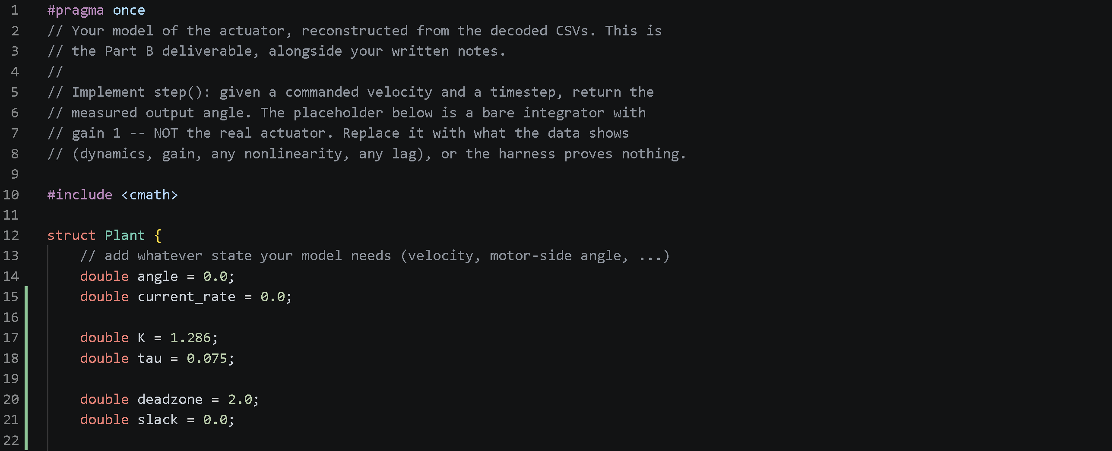
Note:
- Angle was for the output of the degrees of the plant
- Current_rate for how fast the motor is spinning at some moment of time
- K for the gain value, this is the scale value of how hard the motor pushes when the command is given for accurate depiction of the output.
- Tau is the lag or delay, or sluggishness of a vehicle as vehicles don’t start at for example, 60 km/h once the accelerator is slammed (extra notes: The given value in the code above is vastly different from the estimated earlier value (0.075 real vs 0.1895) which was changed because tau was continuously experimented and altered which eventually got the error margin down 1%).
- Deadzone: This is the actual gap where an input in this range doesn’t produce a command
- Slack: Slack is used as a memory within the deadzone and outside of it to, to simulate real-life motorworks (without it, it will be like an on and off switch, in a way that when it hits 2, it will turn on, and when it goes below 2, it would turn off, but its position would not be tracked, thus unrealistic/unreliable).

Now we need to actually capture and update the slack so we know how the motor position is changing within the deadzone and eventually when it goes out of it. Thus a following equation is made using u_command and time to give us the position overtime as shown below:
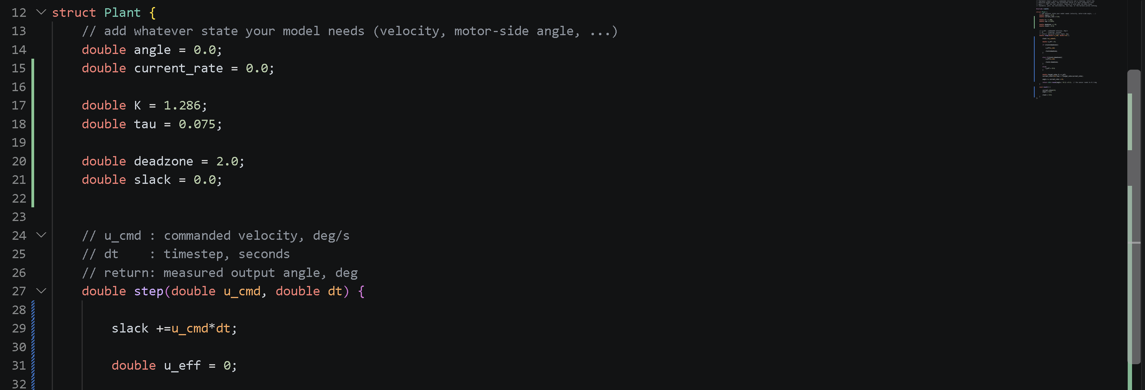

We can now code the actual conditions to check if the output has surpassed the deadzone or not. This is by creating 3 conditional statements that state if slack has surpassed the deadzon or not overtime.
It is basically saying, if for example, slack has surpassed deadzone, then equal that u_cmd value to u_eff (The force input is equal to the force output, thus the plant actually started e.g. turning) (note: u_eff stands for Effective output).
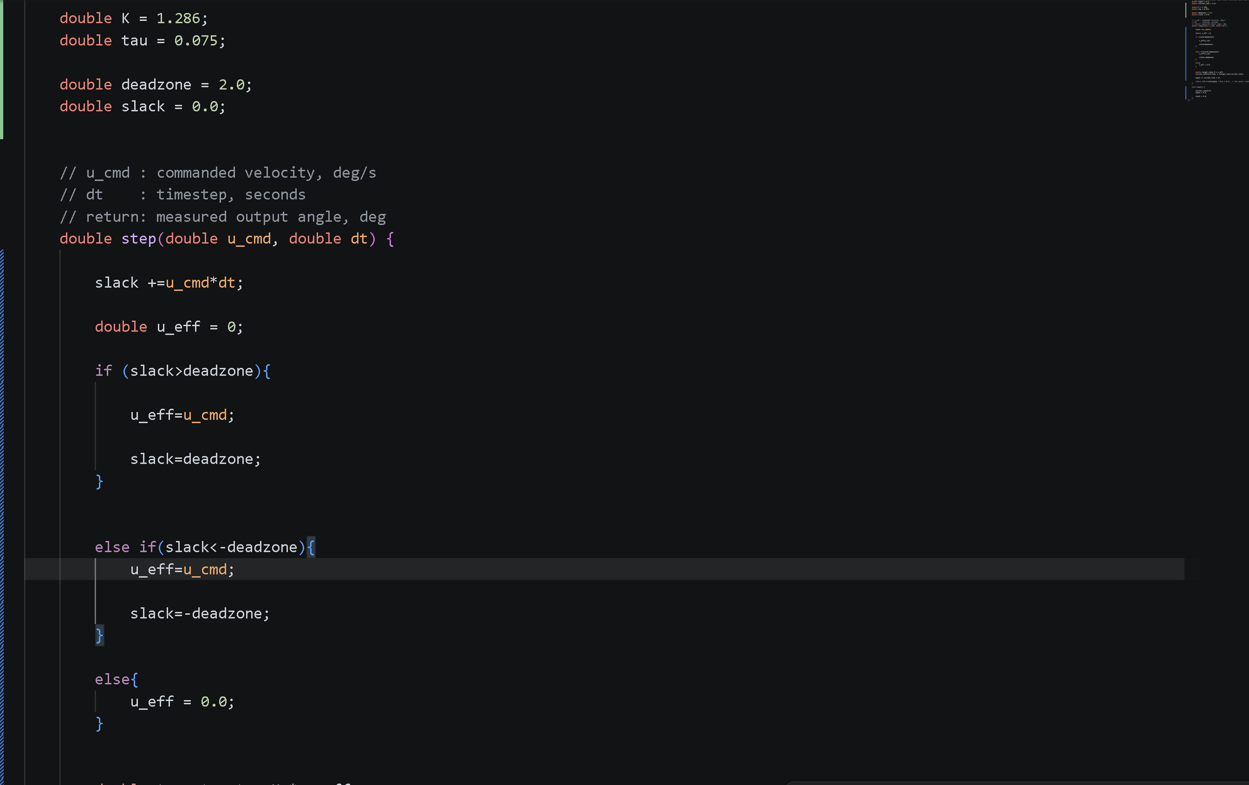
Now we have u_eff, so that when the motor is moving, the motor pushes with a scale factor of K to u_eff therefore reaching a target rate, a rate where the output wants to be at.
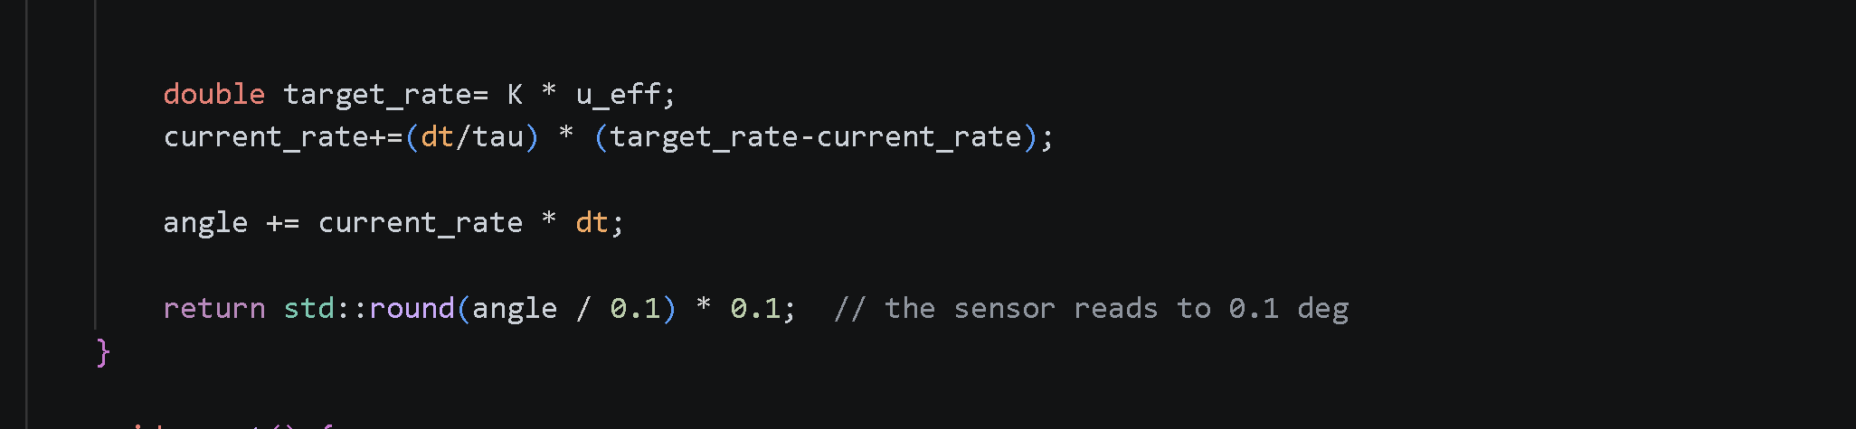
Note:
Current rate is made out of two parts, the right side is the lag, aka, target rate minus current rate and the left side is the fraction of time remaining for the gap to be covered as the motors are moving.

Now after this, we need to reset it for the next loop, thus the values are reset as shown.
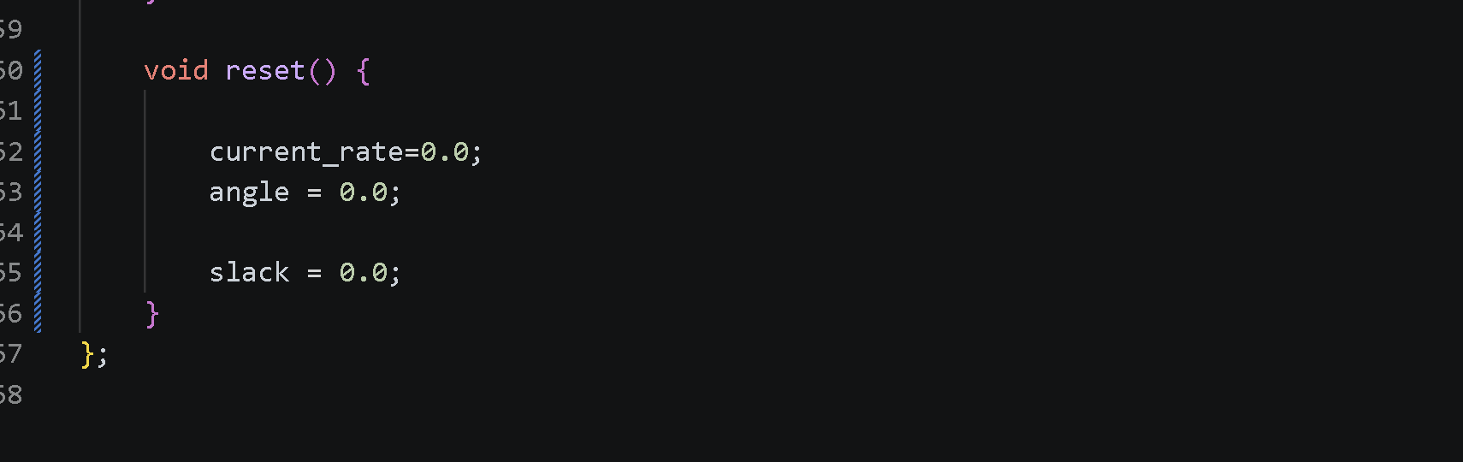

Check 1 was executed and it was successful:
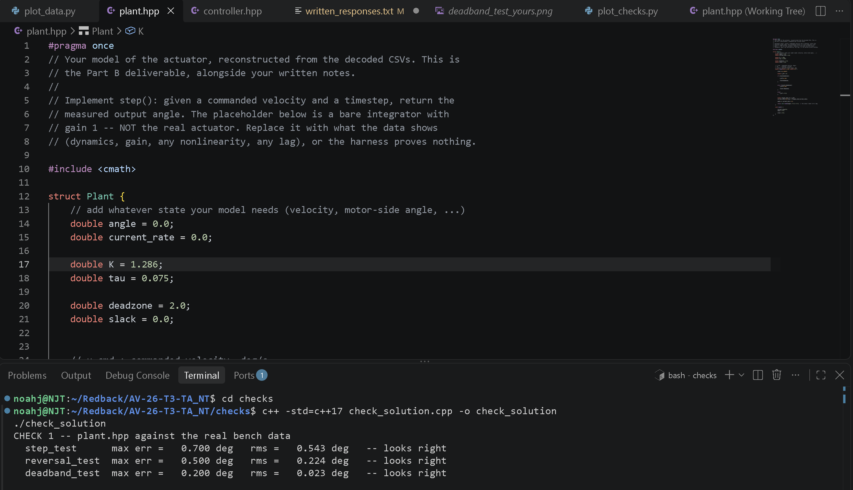

Now the code for the plant is finished, we can start creating the actual controller. This allows us to observe the actual steering data in play with our own code and compare it to a real model. By doing this, we can check if our codes overshoots or undershoots which gives us the information needed to improve on the autonomous steering of the car.

Thus the code is made below:

First we must create a new class called Controller; this allows us to create a system that obeys the rules of the Controller Interface which allows the code to actually run with the redback simulation software. Thus:
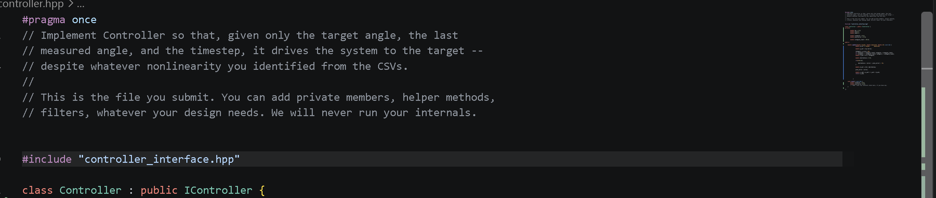

Now we must declare values that we can change only in this file to keep everything safe in this function and not make it interfere with other components, thus labelling them under private. And now we will define the values. First we must define the values of PID (Proportional, Integral and derivative). This is a control loop mechanism that helps reaches, in this case, the steering wheels target degrees from its initial position. Proportional scales the error (target minus measured) which is the gap between the position now and the target and helps scale the wheels “aggression” to hit the target degrees. Integral helps build up error overtime, which assists in correction of the wheel if it has been stuck, for example, 2 degrees off-course of that target that P cannot resolve. Derivative ensures the wheel doesn’t overshoot its target by calculating the change in the error or gap overtime.
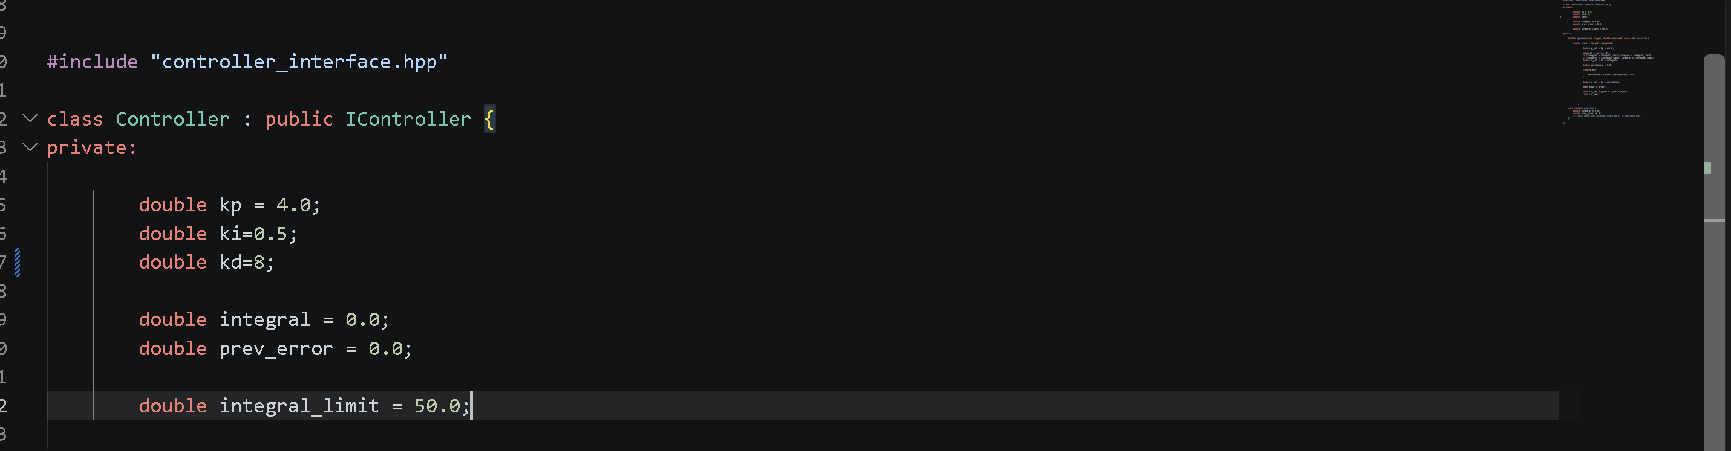

Note:
Kp,ki and kd equal proportional gain, integral and derivative respectively.
Double_integral is set to zero for the start
Prev_error: this stands for previous error which helps the derivative calculate the change in error overtime by keeping the original error.
Integral_limit: This is to prevent Integral windup, which sends the wheel crashing at a very high energy due to accumulative force from the PID loop if the wheel is for example, stuck in trying to reach its desired target. (It accumulates a ton of error so we need a limit to prevent it).

Now we must make a function called update (which we know from IController.hpp) and literally, its job is to update the data as the simulation runs through three variables, target, measured and dt. Override is used to override the old update in IController and tell it to use the one in Controller.hpp:
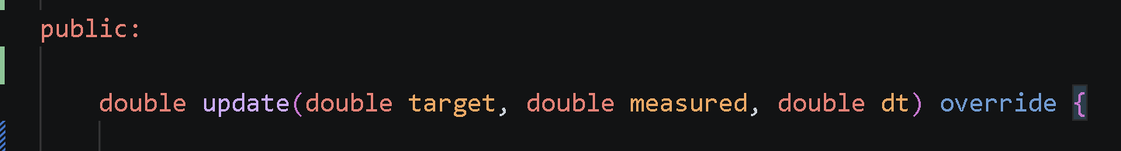
Note: Public is used so other functions can access the data created from here such as check-solutions and plot_check to plot the data.

Now we must create the equations for the simulation. First, we must calculate error to see the actual gap of what needs to be covered for the wheel to even turn, and also, we must calculate the proportional output, which is the power of how fast that wheel will turn based on the error (e.g. a higher error will scale a higher proportional output, making the wheel turn more aggressively to reach the target due to the bigger distance needing to be covered):
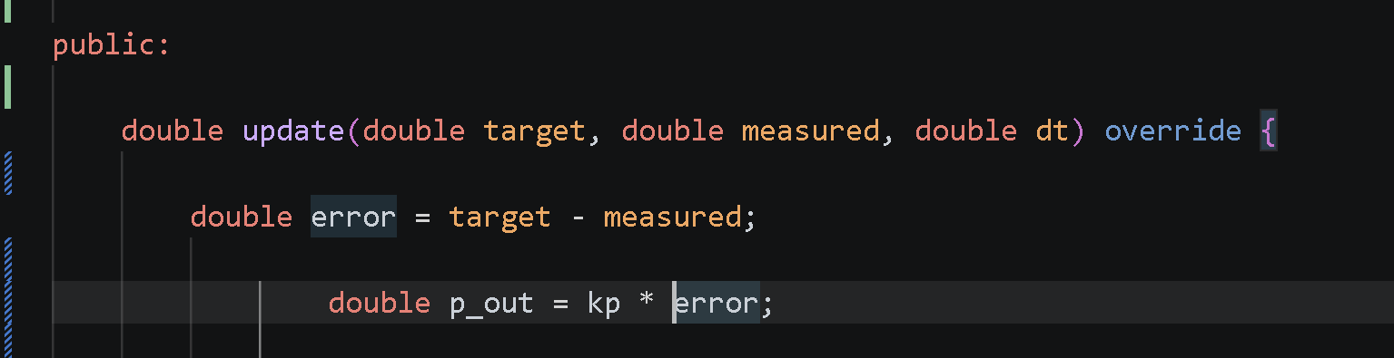
Now we must create an equation for the integral. A computer measures time in ticks (0.01 seconds or some really small amount of time) and it continuously adds that number to a certain error, (e.g. it has been at 8 error for 2 seconds, the integral would be 8 * 0.1 for example again and again in that range, building up error), and it also must be scaled by ki (integral gain) which helps output a safe power so the wheel can efficiently but also safely reach its target without overshooting. And also, an integral limit inequality was also made to combat the infinite error build up which will cause very aggressive steering issues (the car wont move properly and might jerk):
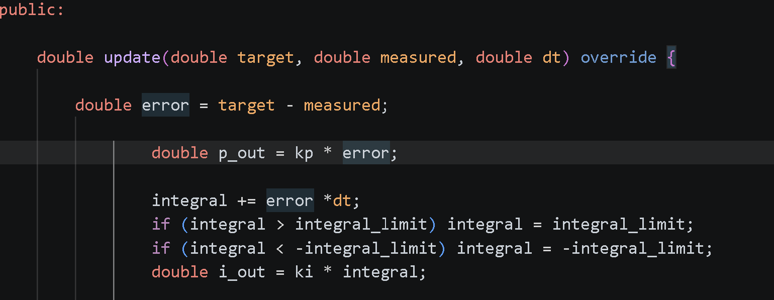

Now we must write an equation for the derivative. Derivative helps us calculate the change in the error overtime so it can prevent any overshoots as it can help slow down if its moving too fast to the target. The prev_error (previous error) variable is used to store the past error that precedes the most recent one. This helps keep track of how fast it is changing overtime and updates it:
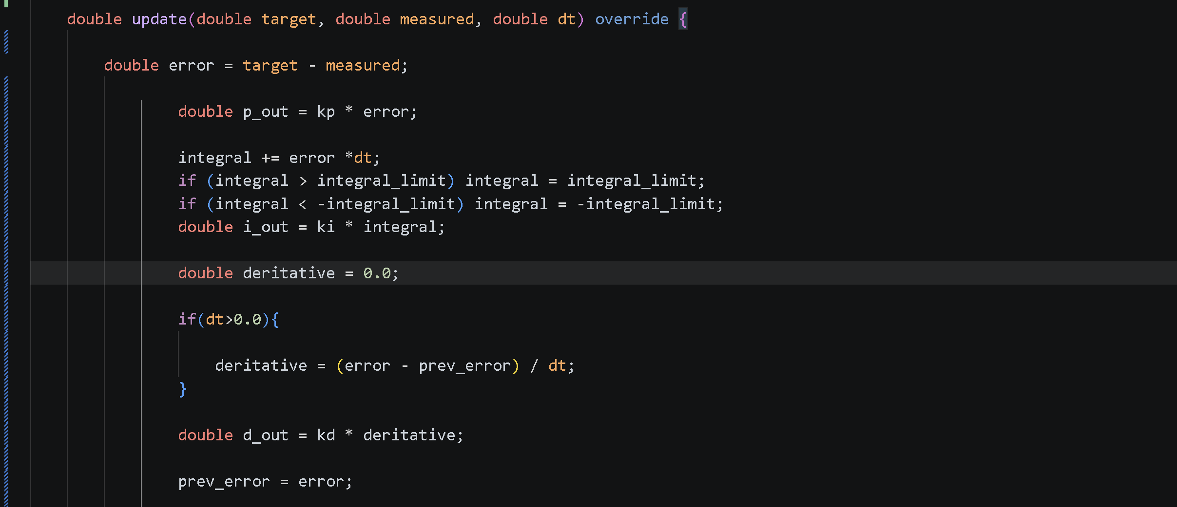

Now we must find the control output, the actual u_cmd value. To do this, we follow the given equation of control output in PID and then return it to the rest of the program so it can actually be outputted. This is,
$$u(t) = P + I + D$$
Or in this case
$$u_cmd = p_out + i_out + d_out$$
Therefore:

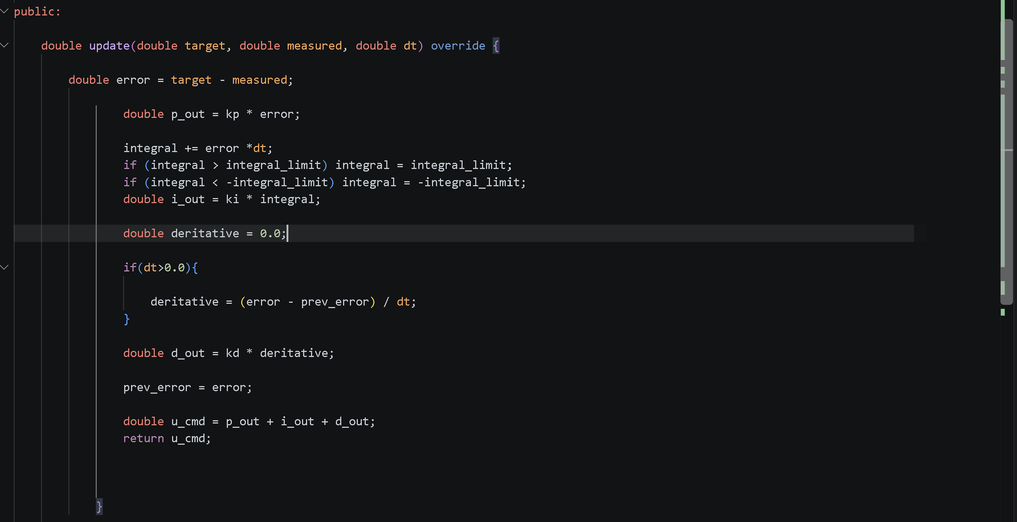

Most Importantly, if we restart the test, we need the function to wipe its whole memory so it can start fresh. So the following function is made:
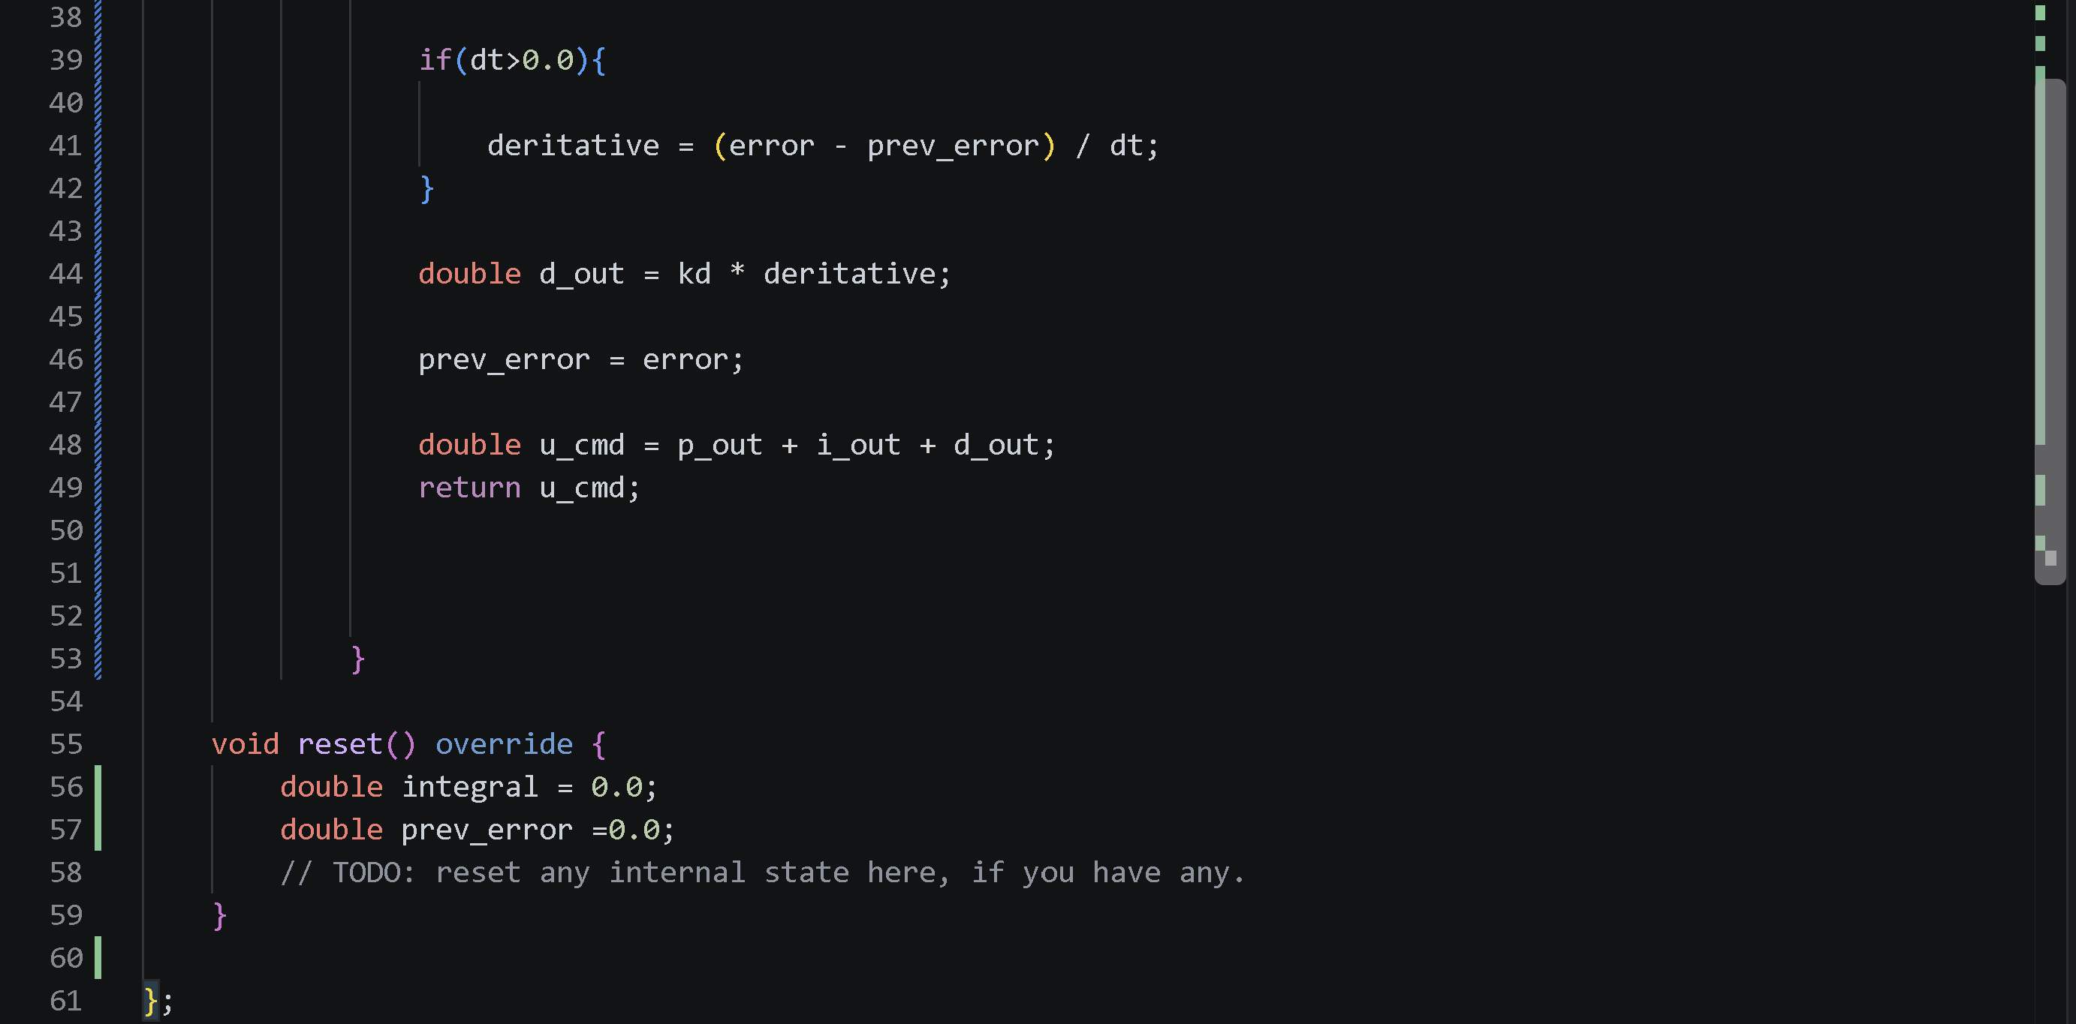
Note: Only these two because they are the values inside private and can change whereas variables in public are instantly removed once the test is cut.

Thus with the code finally accomplished the following check is completed:
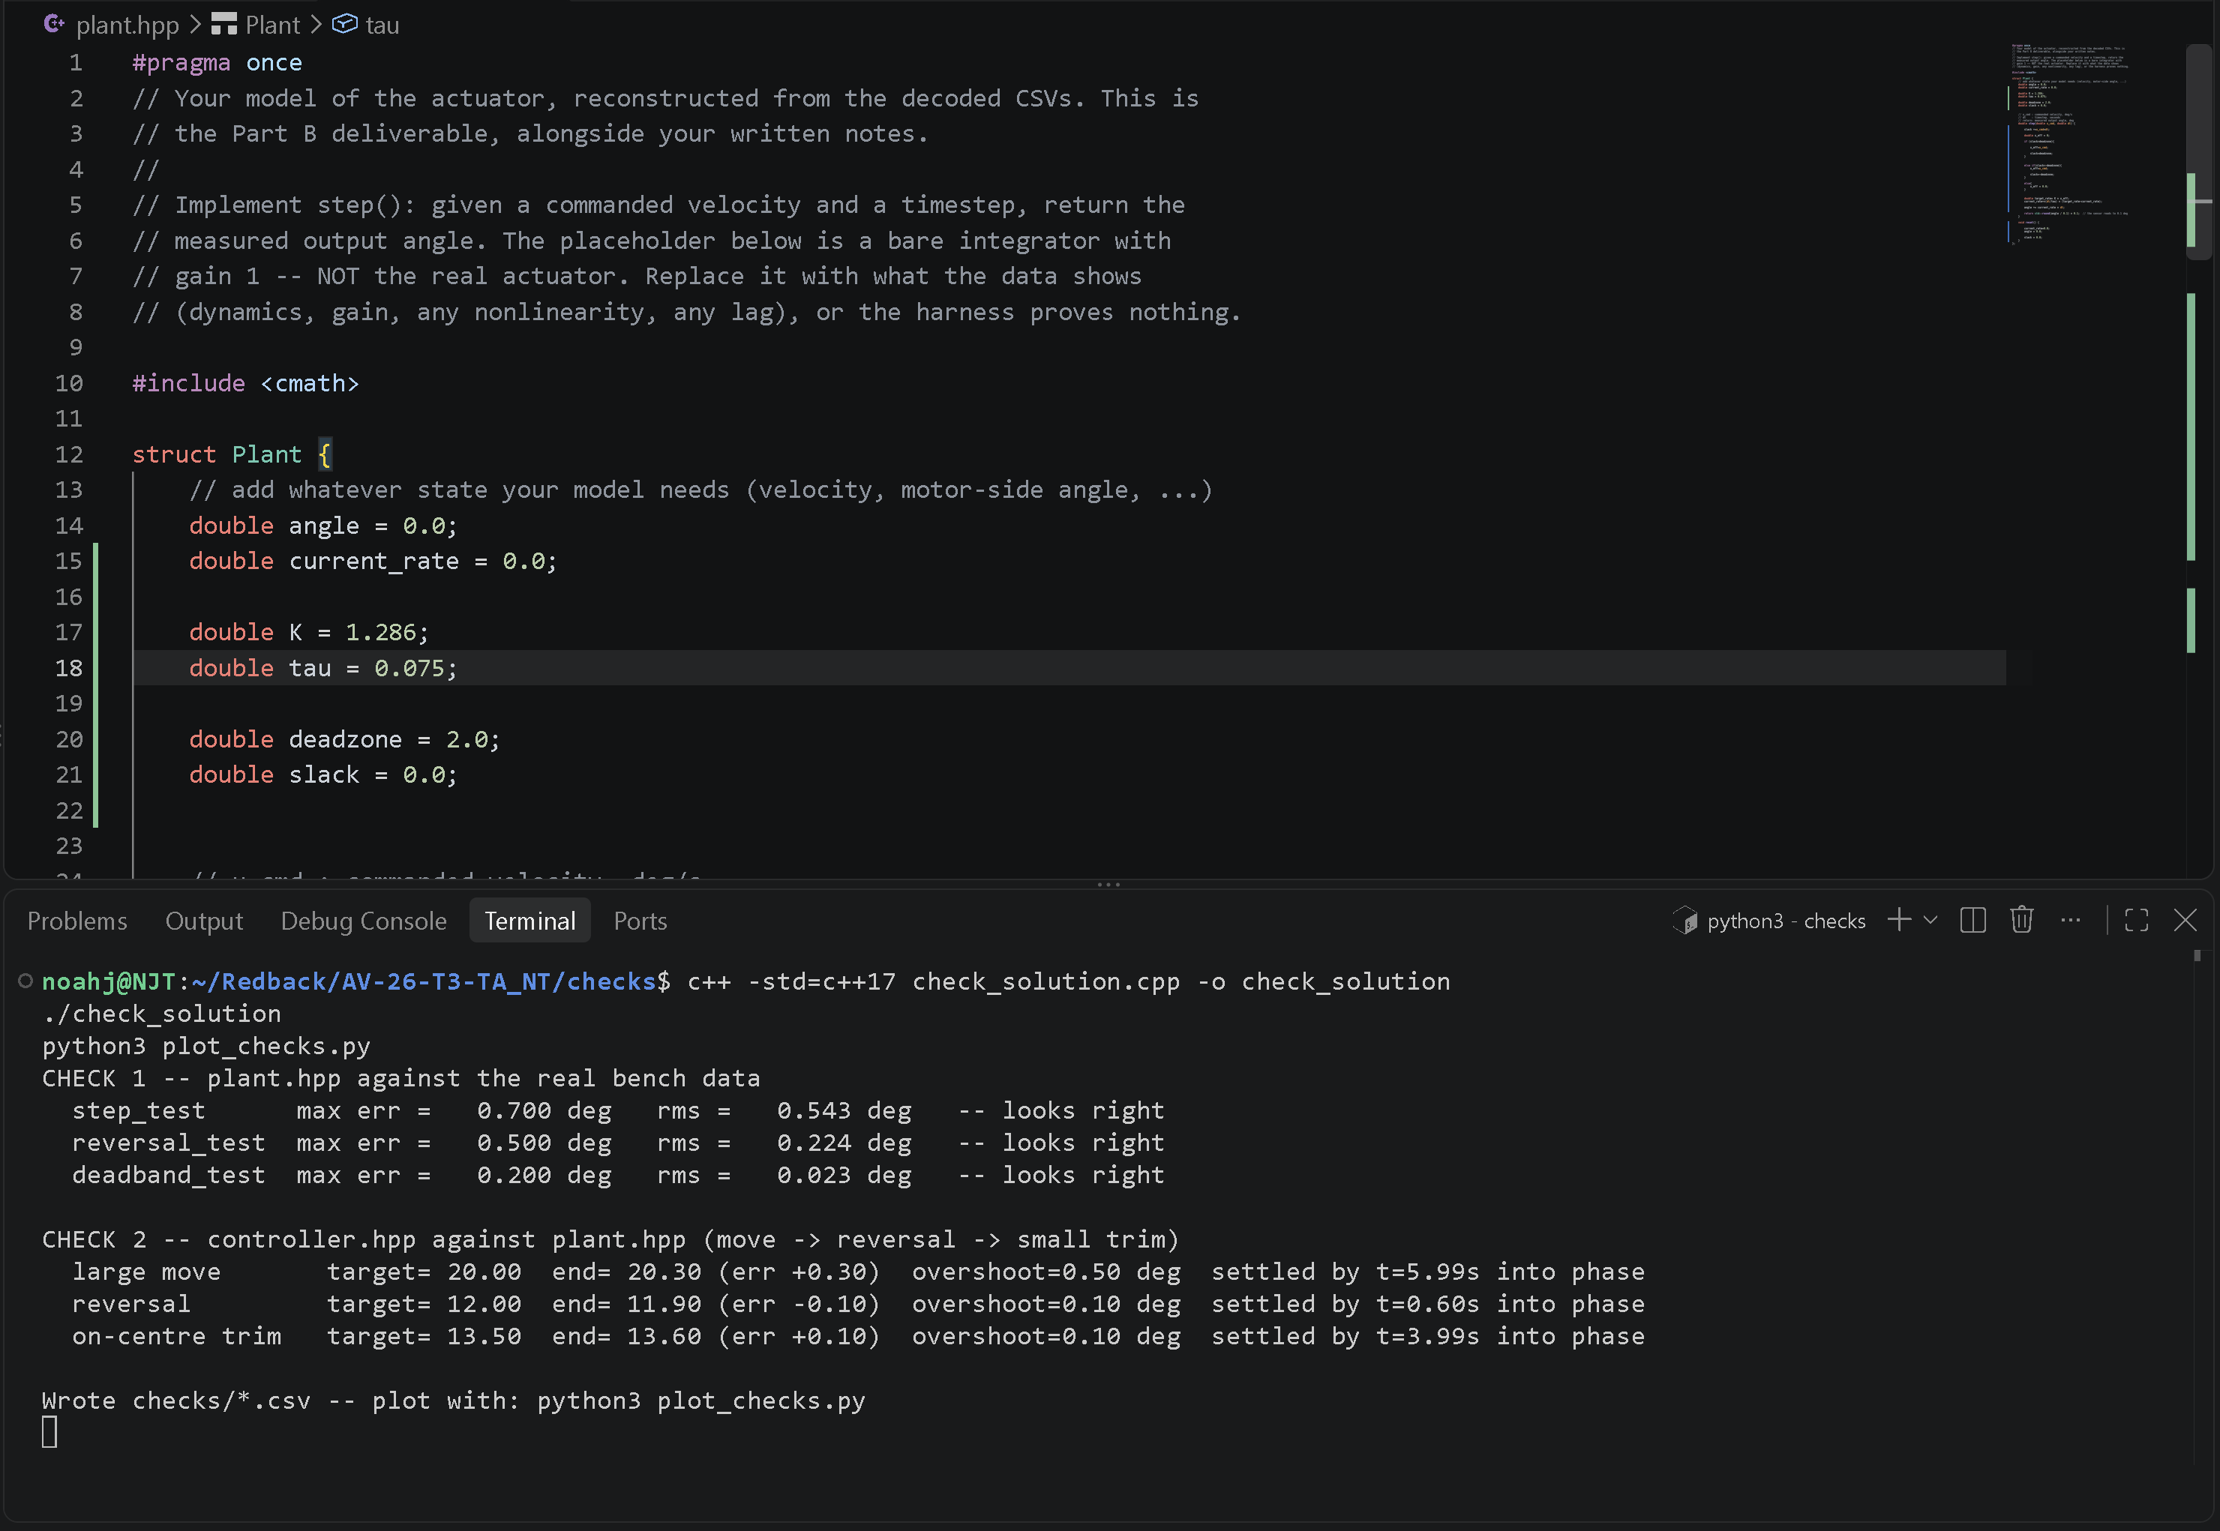
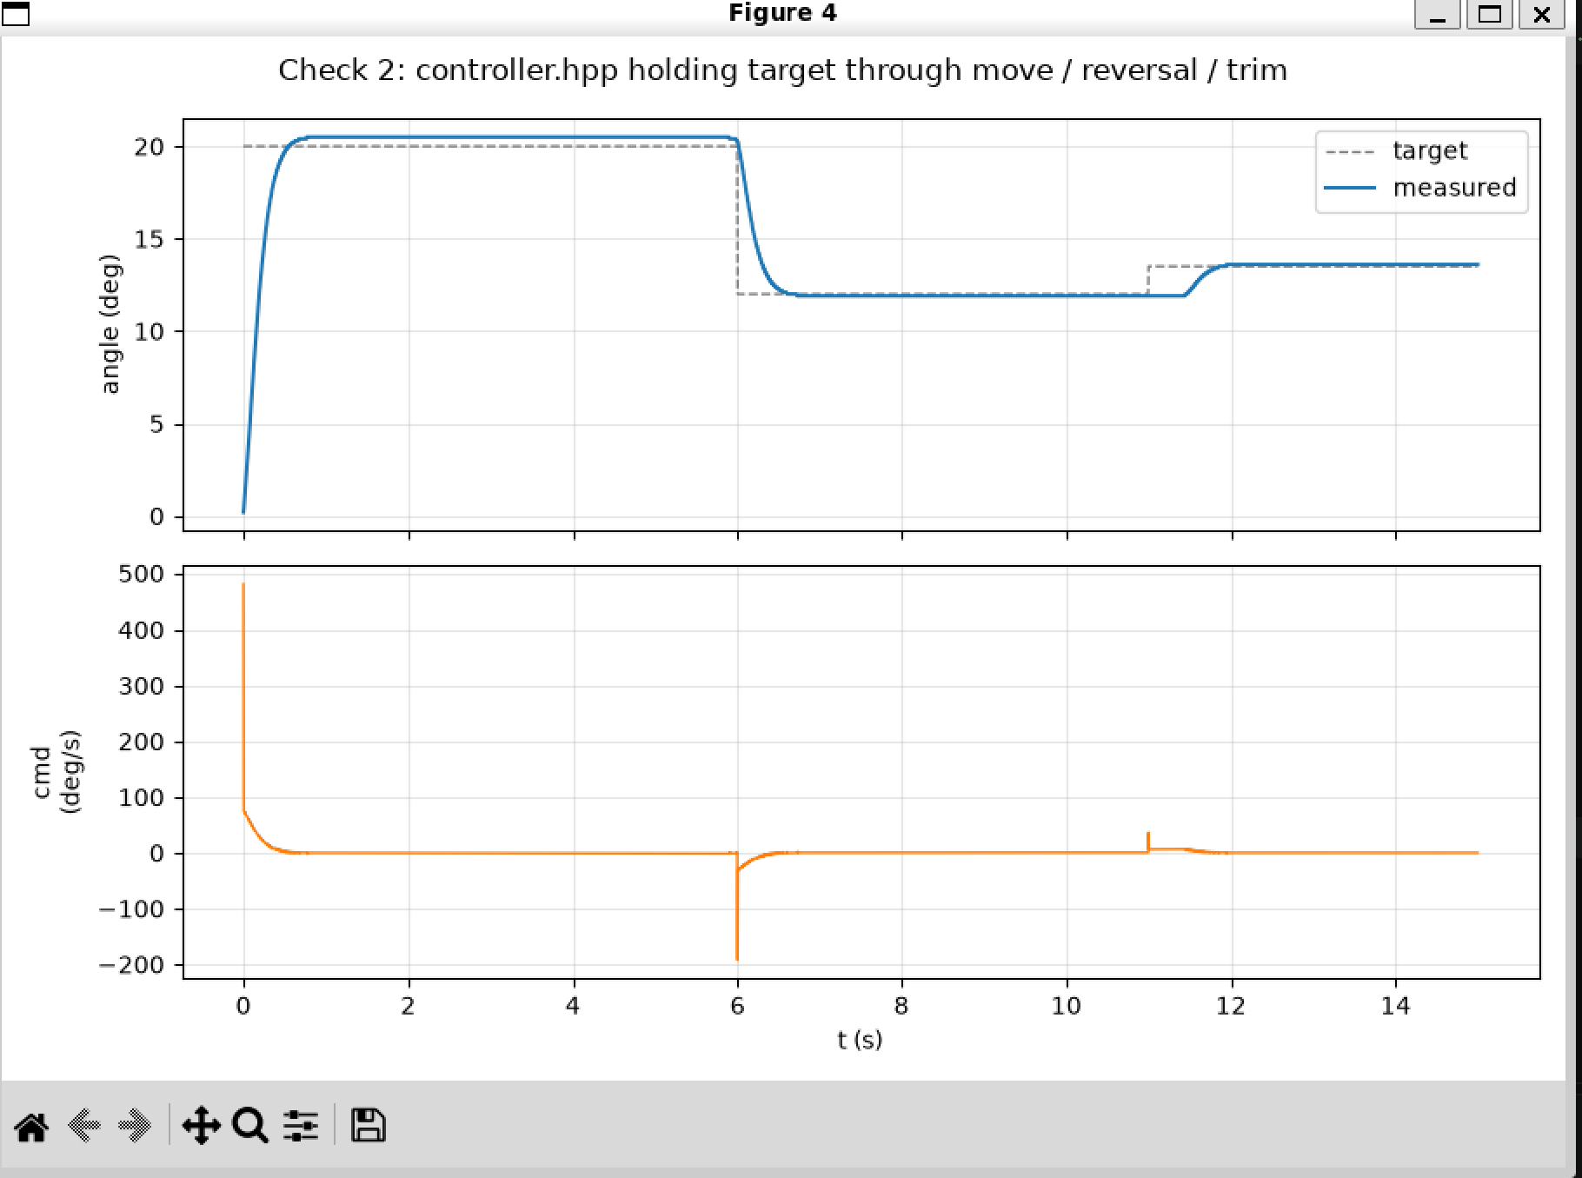
Analysis:
The graph shows an accurate representation of the comparison between the measured (my_code) and the target. We can see that at a target angle of 20 degrees from times 0.3 seconds to around 6 seconds, there has been an overshoot from the measured line of 20.3 producing a 0.3 error. Additionally, at 6 seconds, there is a massive overshoot where the measured value glides over the target from 20 degrees to around 12 degrees whilst thes change in the target was immediate . In the timeframe, 6 seconds to around 11.3 seconds, the measured and target line are tightly bonded with an error of 0.1 from the targets 12 degrees to our 11.90 degrees accuracy however once again, the measured target undershoots at around 11.5 seconds. But at 12 seconds, both lines re-merge with an error of 0.1 with the target having 13.50 and the measured having 13.60.
This showcases the a near-close modelling of the measured to the target however further considerations of improving the model must take effect. This may possibly be due to getting one of the PID values wrong or suggesting a better integral limit.

